UConn ECE4211 Home Work Set #1 1/17/2017, Due 1/24/17 F. Jain, NAME:________________
fcj@engr.uconn.edu, Office: ITEB 465) hours: Tu 9:15-9:45am; Th 9:15-10:45am;
For posting of course material, see Link: http://www.ee.uconn.edu/undergraduate-program/course-pages
REVIEW SET: Chapter 1; Q.1-Q8 will be solved in class. Q11 related to background of Differential Equations

Q1 Crystalline solids form lattices which are body center cubic (BCC), face centered cubic (FCC), and diamond cubic. The diamond cubic arrangement is shown in Fig. 1 (or Fig. 6a page 11 of Notes).
(a) How many neighbors one Si atoms has? Circle one: 2 4 3 1

(b) Draw a 3-D sketch of Si atom and its neighbors.

(c) What do we call this arrangement?

(d) What is the bonding in Si diamond lattice (Circle one)
Covalent or ionic or both

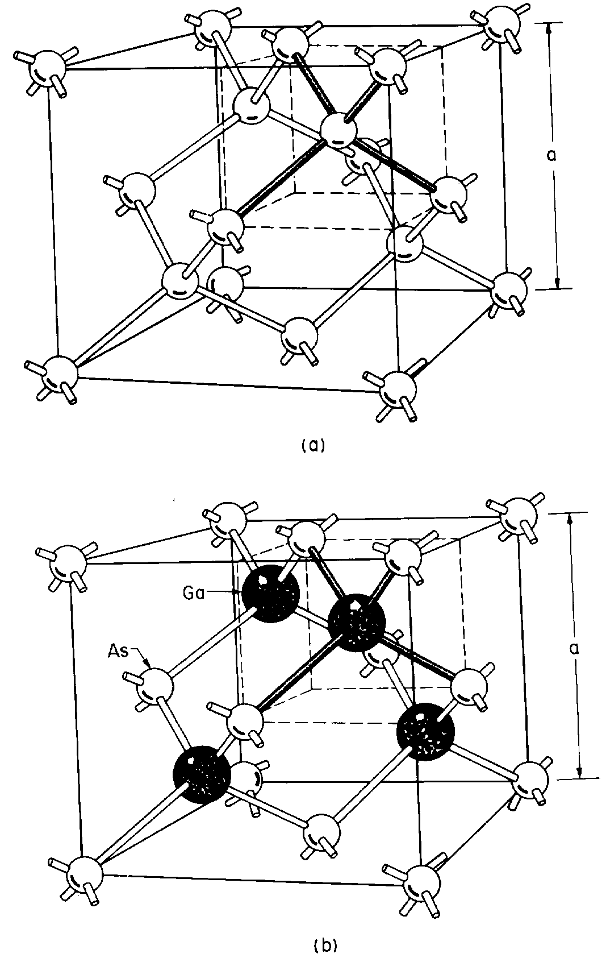  Fig .1a Si lattice (all atoms same) top;  (b) GaAs lattice (Ga and As atoms) open and dark circles. | 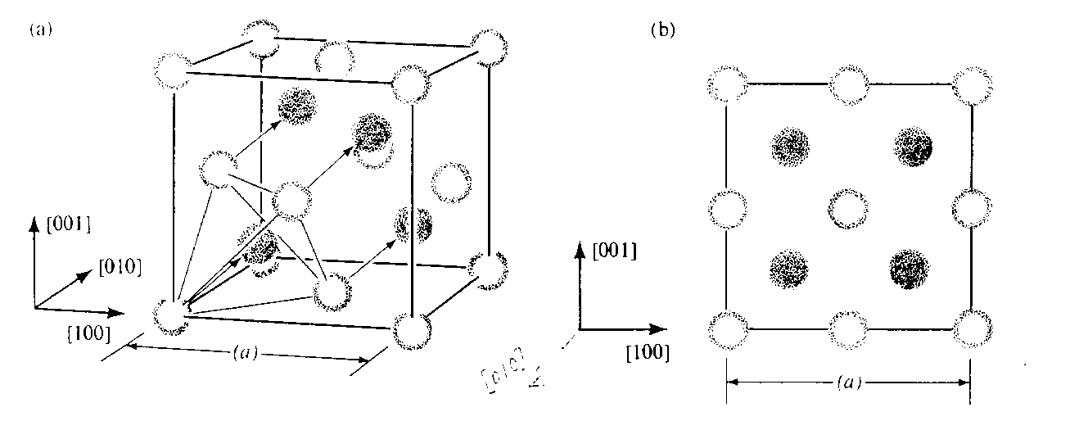  Fig. 2. In the case of GaAs or ZnS, each Zn atom (circle) has four dark shade circle neighbors (Fig. 2b right) or one dark shade circle has four open circles.

Q.2 The atomic number of sodium (Na) is 11 and its electron distribution is given in Fig. 3 [page 14/Fig. 9 Notes]. There is one electron in the outer shell 3s.
(a) Circle one: The outer 3s shell of sodium is filled partly filled
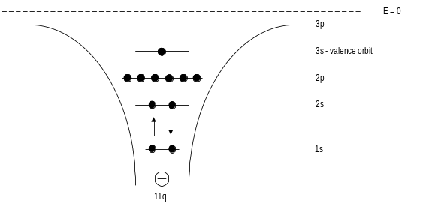 | 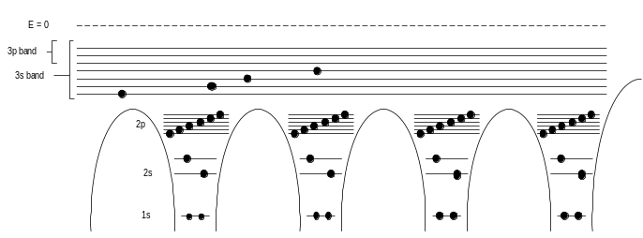
Fig.3. Energy levels and electrons in one sodium atom. | Fig. 4. 3s and 3p energy bands in a chain of 4 Na atoms.

(b) In a solid chain of sodium atoms, the outer electrons (1 per each atom) are shared between neighbors. The discrete energy levels in a single sodium atom become energy bands (in which energy levels are very close to each other) as shown in 4 [Notes Fig. 11]. Will sodium chain behave like at room temperature? Circle one
metal or semiconductor or insulator.
(c) Based on information in part (b), can we conclude that solid Na will conduct electricity via electron flow in a when an electric voltage or field is applied. Circle one YES NO
Q 3.Si atom has 14 electrons as its atomic number is 14. The electron distribution (shown on page 17) is:
2 electrons in first 1s level (spin up and down; shell n=1),
2 electrons in 2s,
6 in 2p, (2s and 2p combination forms shell #2 (n=2) with 8 electrons.
2 are accommodated in 3s and
2 in 3p (this leaves 3rd shell partially filled having 4 electrons as it can accommodate 8).

(a) Based on this information, will Si behave like a metal or semiconductor? Circle one.

(b) We know that Si is a semiconductor. Explain how 4N outer electrons in N atoms of Si solid are arranged when a solid is formed to result in a semiconductor.

HINT: This is explained by invoking sp3 hybridization? (Hint: see Fig. 15 page 19). That is, 3s electron orbital and 3p orbitals get combined/hybridized. Their 8N states divide into two energy bands as shown in Fig. 17. Four outer electrons of each Si atom contribute 4N electrons in a solid comprising of N Si atoms. These 4N electrons fill the lower energy band. The upper energy band remains empty.

(c) What do we call the energy band that is filled first? Circle one Conduction band Valence band
(d) Circle one: is molten Si conducts like metals or semiconductors

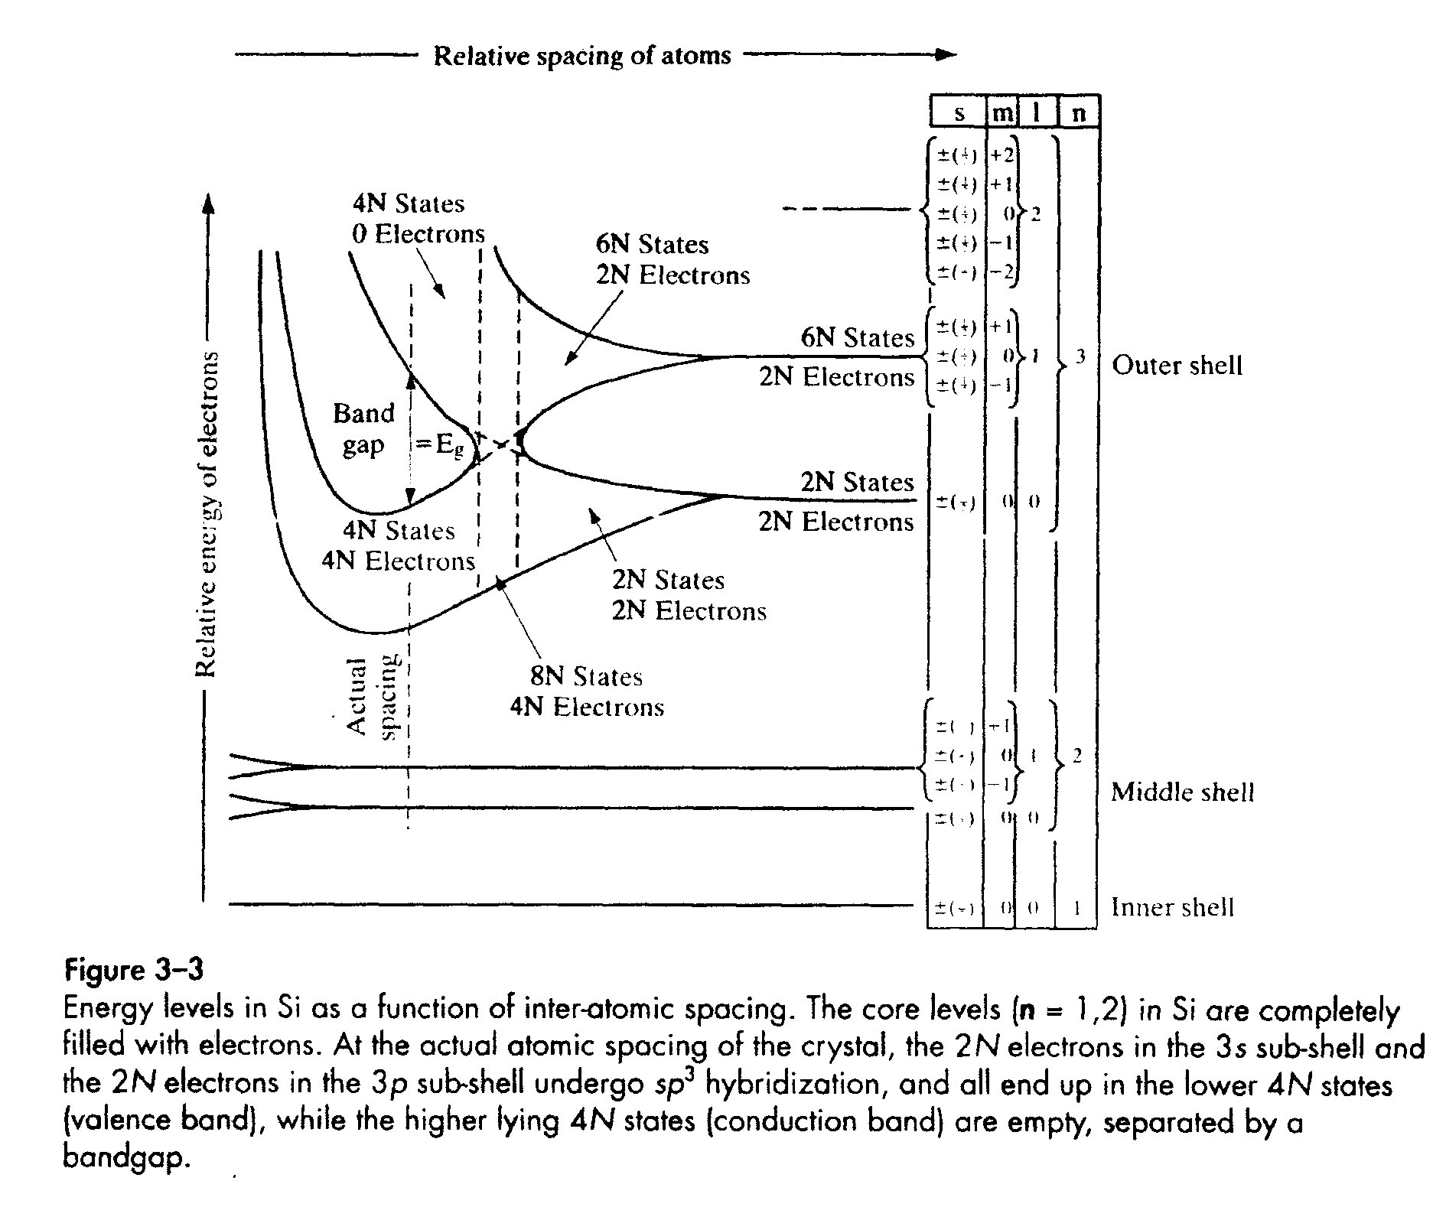
Fig. 5 [Fig.17 page 19]
Formation of energy bands from discrete levels when Si atoms are far apart. When Si crystal or solid is formed, atoms get closer and their electrons start interacting (like shown in Figs. 11/12 notes.)
Two bands are shown at the location of double headed arrow.
Q.4 (a) In Fig. 5 the upper band which is identified by “4N states 0 electrons” is called
Conduction band Valence band
(b) Do all semiconductors have an energy gap E_{g} as shown in Fig 5. Circle one.

‘ True False
(c) Generally at 0°K, the lower of the two energy bands is completely filled up with electrons and upper band is empty. Does this make Si an insulator semiconductor metal

(d) At finite temperature T, some electrons statistically (though the probability is very small) leave the lower or valence band and make transition to the upper or conduction band.
Will Si conduct electricity Circle one.
YES or No
(e) When few electrons from a fully filled valence band make transition to the upper band (conduction band), they leave behind unfilled energy states. What do we call these states?
holes OR acceptors
Q. 5 (a) Do electrons in the valence band conduct electricity? Circle one
Yes No
(b) Can there be holes in the top or conduction band? Circle one
Yes No
(c) Semiconductors have both electrons and holes that enable current conduction.
True False
Q. 6a. In a pure (intrinsic) Si, there are equal number of electrons and holes. Circle one
Yes No

Q.6b The number of electrons and holes goes up as the operating temperature T of Si raised. Circle one
True False

Q7. (a) What is the charge of a hole (circle one)
+q -q
q=1.6x10⁻¹⁹ Coulombs.
Q. 7(b) When electron concentrations in the conduction band and hole concentrations in the conduction band are in equal numbers (that is, n = p = n_{i}) the semiconductor is known as intrinsic semiconductor. Does the value of n_{i} depend on energy gap E_{g}?

Q. 8 Carrier concentration of an intrinsic semiconductor can be changed by adding impurity atoms which donate (electrons to the conduction band) or accept electrons from the valence band. They are called donors (N_{d}) and acceptors (N_{a}), respectively. The impurity atom concentration is usually fraction of Si atoms per unit volume.

(a) If a Si atom is replaced by boron which has 3 outer electrons, does it behave as a donor or acceptor.

8(b) What happens if Si atoms are substituted by Phosphorus atoms, does it behave as a donor or acceptor.

8(c) what determines if the donor atom will donate the electrons or not?

Q.9 Semiconductors have more donors (or no acceptors) are called n-type semiconductors as they have more electrons in the conduction band, and semiconductors having more acceptor atoms behave as p-type as they have more holes. Unlike metals, semiconductors consist of both electrons and holes.
The product of electron (n) and hole (p) concentration, under equilibrium, is constant np=n_{i}².

(a)Find electron concentration in the p- region (n_{po}) and hole concentration in the n-region (p_{no}) of a p⁺-n diode shown in Fig. 6. Here, subscript p refers to the p-region, primary character n refers to n-Si, subscript ‘o’ is for equilibrium.
Given n_{i} in Si at room temperature (T=300K) =1.5x10¹⁰ cm⁻³; the product of hole concentration p and electron concentration n outside the junction is constant pn = (n_{i})² Assume all donors and acceptors are ionized at 300K.

(b) Plot the hole and electron concentrations in the p⁺, n regions, and in the junction region for the p⁺-n Si diode of Fig. 6. {Concentration of holes in p-region and electrons in n-region are shown}.

Q.10. Si is available in single crystalline, poly crystalline, and amorphous forms.
(a) Is the energy band gap same for crystalline and poly-crystalline? Circle one
YES NO
(b) Is the energy band gap of crystalline and amorphous Si same? Circle one
YES NO

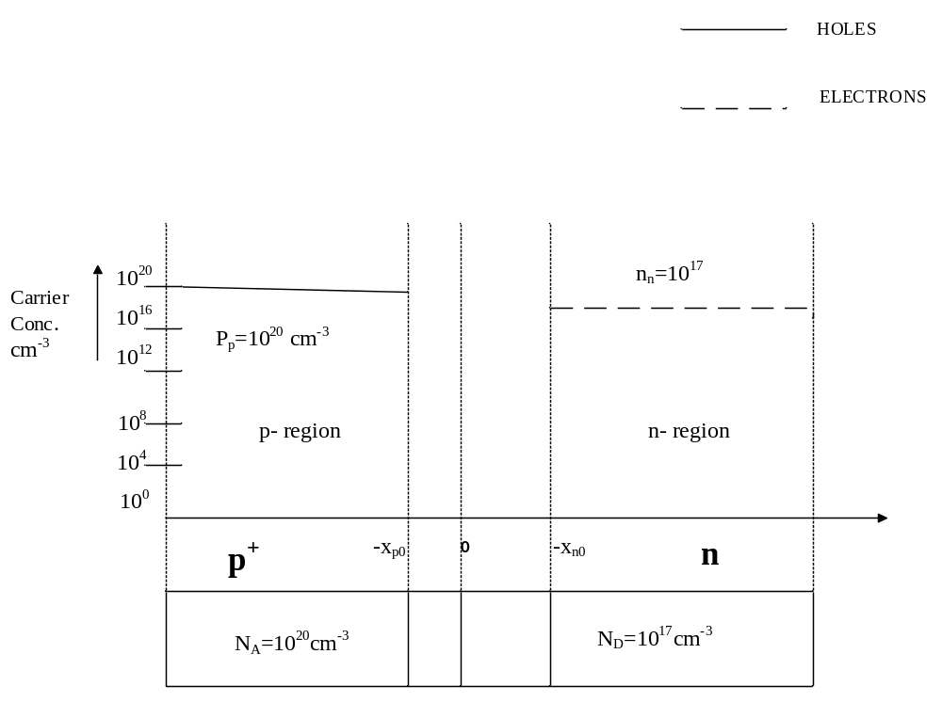 Fig. 6 Schematic of a p⁺-n junction under equilibrium.
Q.11. (a) Show that the solution of Schrodinger equation 1 (pages 20-21) 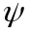is expressed by Eq. 3. This is obtained by solving in an infinite well for the boundary conditions ψ(x=L)=0 and ψ(x=0)=0.
(b) Find values of three energy levels from Eq. 2 using t n=1, 2, 3. HINT: find k_{x} from Eq. 3 boundary conditions.
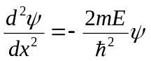 (1) where 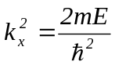 (2)
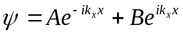 (3)
Q.12. which of following expression is valid for density of states in a conduction band?
(a) Circle one Eq. 14 or Eq. 15.
N(E)dE = 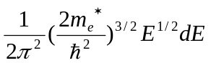 (14)
N(E)dE = 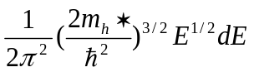 (15)
(b) Label three equations as Fermi-Dirac (FD), Maxwell Boltzmann (MB) and Bose-Einstein (BE) distribution.
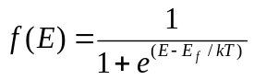 FD MB BE
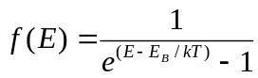 FD MB BE
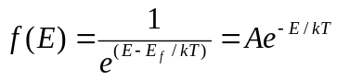 FD MB BE

