UConn/ECE4211 HW #7 Lasers-I: 03/02/2017, (Due 3/9/17) F. Jain Name___________

Q.1(a) What is the ratio of rate of stimulated emission to rate of absorption if the energy balance equation is given below? (L7-Slide 5)
A₂₁N₂ + B₂₁ ρ(hn₁₂) N₂ = B₁₂ ρ(hn₁₂) N₁

(b) What is the ratio of rate of stimulated emission to rate of spontaneous emission using above equation.

(c) What do real and imaginary term represent?
If the propagation constant in a laser cavity is given by Eq. 7(b) page 339 Noes
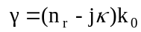 (7b)
we can rewrite Eq. 7b for the propagation coefficient as
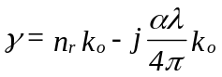 (8a)
Using 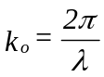and substituting in Eq. 8(a) 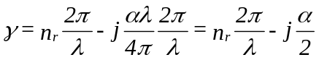 (8b)

A more general form of Equation (8b) includes g, the gain coefficient of the lasing medium
(d) Can we generalize propagation constant by incorporating gain coefficient g as in Eq 8c? Circle one. YES NO

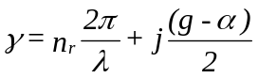 (8c)

Q.2. Figure below shows the schematic cross-section of a single mode ridge waveguide semiconductor laser. (Slide 2 L7)
(A) Show three layers forming the double heterostructure.
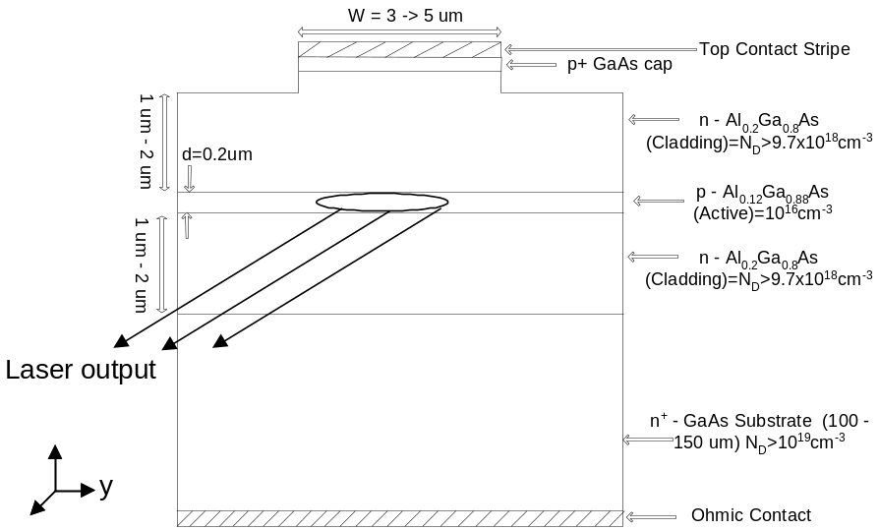
Fig .28. (NOTES) An edge-emitting cavity laser with ridge waveguide.

(b) Which faces forms the cavity here.

(c) What is the role of ridge in the upper cladding layer.

(d) Label the layer where injected electron and hole recombines and emit photons and photons are guided.

(e) Is the index of cladding layers higher or lower than the active layer? Circle one.

Q3. (a) Figure shows the layer where grating is formed and results in distributed feedback in the DBF laser. What is main factor resulting in grating formation.
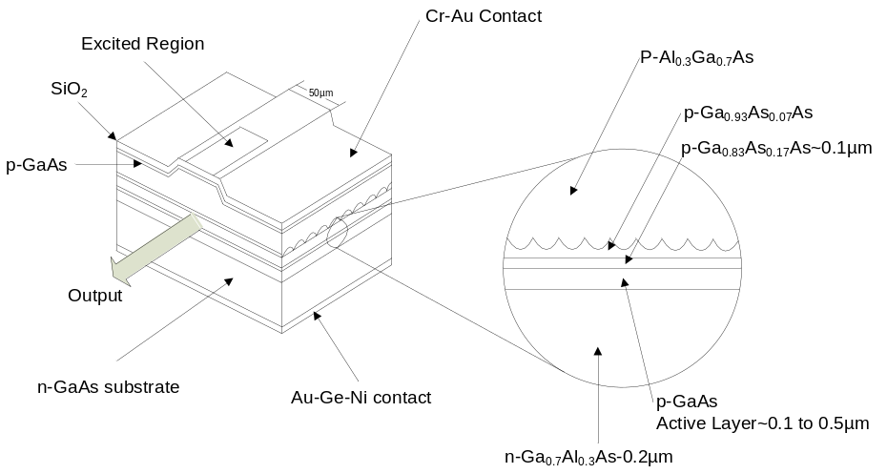
Fig .48 Distributed feedback (DFB) edge-emitting laser (first order grating).

Q3(b1) Figure below shows the cross-section of a vertical cavity surface emitting laser. What is the role of dielectric mirrors?

(b2) Where is the active layer (figure 26 on left)?
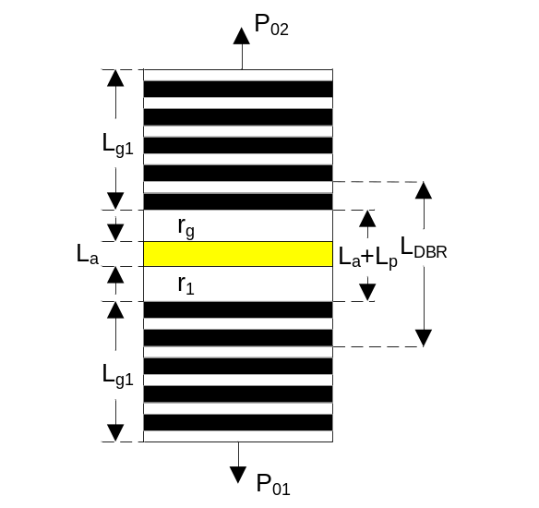 | 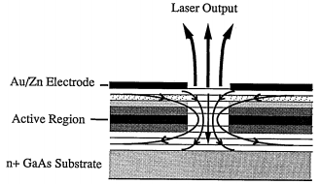
Fig. 56 In a vertical cavity surface emitting laser (VCSEL) the cavity thickness is multiple of half wavelength. The dielectric mirrors are formed by stack of hi and low index quarter wave layers. | Another view of VCSEL
Q.4 (a) Compute the photon density ρ(hν)in the region shown by a box of thickness 2L_{n}, width W and length L (Fig. 6) in p-GaAs side. Assume the forward current I is 10mA. The top contact stripe has a width W=5 μm and L = 500 microns (in z-direction). Assume injection efficiency to be 0.999 and quantum efficiency to be 0.95. The diffusion length L_{n}= 1 μm.
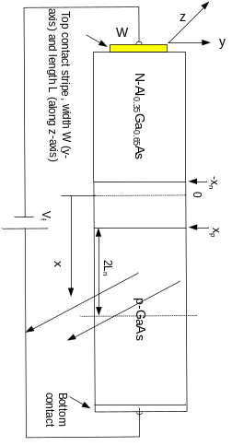 | 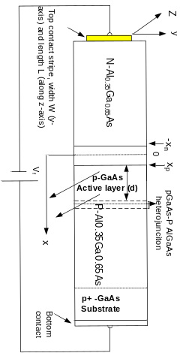
Fig. 6 An abrupt n⁻AlGaAs-p GaAs single heterojunction (SH) diode under forward bias. | Fig. 7 An n⁻AlGaAs-p GaAs-P AlGaAs double heterojunction (DH) diode under forward bias.
(b) Compute the photon density in the active layer GaAs of double heterojunction (DH) diode of Fig. 7. This device has the same contact stripe W on Al_{0.35}Ga_{0.65}As, and thickness of p-GaAs is d= 0.1 μm, and length L =500 μm in z-direction in the double heterojunctions (DH) diode.

Q5(a) Find wavelength λ_{m}, λ_{m+1}, and λ_{m-1} of three successive cavity modes for the In_{0.65}Ga_{0.35}As_{0.75}P_{0.25} active layer with a cavity length of 500micron. The index of 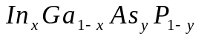is given by (j)
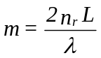 or use Eq. 22 Chapter 5 with dn_{r}/dλ from 1.5.
(b) What is the procedure of finding the composition of InGaAsP lattice matched to InP to emit 1.55 micron. Note laser is different from LED due to Bernard-Duraffourg condition.

Q. 6. (a) The energy band diagrams for the diodes of Fig. 7 is shown below. Justify values of ΔE_{c} and ΔE_{v} at heterostructure boundaries. .
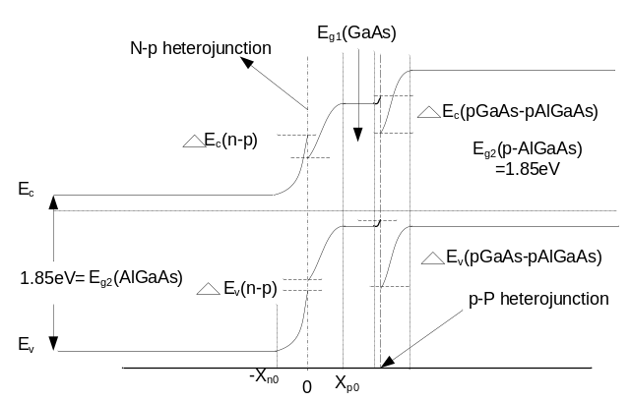Fig. 17 Notes
(b) What is the role of pGaAs-pAlGaAs (iso-type) heterojunction in confining the injected electrons in the p-GaAs layer?
BONUS Questions (c) Find the forward bias current at a V_{f} =1.2V in the device Fig. 6.
Given: n⁺-side: Donor concentration N_{D}= 2x 10¹⁸ cm⁻³
minority hole lifetime τ_{p}=2×10⁻⁹ sec.
Minority hole diffusion coefficient D_{p}=10 cm²/sec.
Intrinsic carrier concentration n_{i} (AlGaAs)=300 cm⁻³
p-GaAs : Acceptor concentration N_{A}= 3x10¹⁶ cm⁻³, All donors/acceptors are ionized.
τ_{n}=10⁻⁸ sec. D_{n}=100 cm²/sec; Junction area A=10⁻³ cm⁻², ε₀=8.85×10⁻¹⁴ F/cm, ε_{s}=ε_{r}ε₀. T=300 °K.
Intrinsic carrier concentration n_{i} (GaAs) ~ n_{i}(AlGaAs) * exp[+ΔE_{g}/2kT] = 300 e^{+ΔEg/2kT} cm⁻³ [Here, ΔE_{g} = E_{g}(AlGaAs)- E_{g}(GaAs)]. Find the n_{i} for AlGaAs.
p-AlGaAs: same as n+ side except it is doped with acceptors.
Additional information: Given: n-side Al_{ξ}Ga_{1-ξ}As:
Effective mass: electrons m_{e}=m_{n}= (0.067 + 0.083ξ)m_{o}, for ξ < 0.45;
Energy gap E_{g} (Al_{ξ}Ga_{1-ξ}As) = 1.424 + 1.247ξ (for ξ<0.45); and
E_{g} = 1.9 + 0.125ξ +0.143ξ² (for ξ>0.45). ΔE_{g}= 1.247ξ (for ξ <0.45).
Dielectric constant: ε = 13.18 –3.12ξ, and ε_{o} = 8.854x10⁻¹⁴ F/cm
p-side: Effective mass of holes (density of states calculations) m_{h}=m_{p}= [(m_{lh})^{3/2} + (m_{hh})^{3/2}]^{2/3} m_{o},
m_{lh} = 0.087 + 0.063 ξ, and m_{hh} = 0.62 + 0.14 ξ [for GaAs, ξ = 0].Electron affinity in GaAs qχ = 4.07 eV. HINT: Electron affinity of AlGaAs can be obtained from the following relation.
qχ₂ (Al_{ξ}Ga_{1−ξ}As) = 4.07 - ΔE_{c}, as qχ₁−qχ₂ =ΔE_{c}; ΔE_{c} = 0.6 ΔE_{g} where ΔE_{g}= 1.247ξ.
[ΔE_{c}/ ΔE_{v} = 60/40 (i.e. ΔE_{c} = 0.6 ΔE_{g} where ΔE_{g}= 1.247ξ;
and ΔE_{v} = 0.4 ΔE_{g}); as ΔE_{c}+ ΔE_{v}= ΔE_{g}, ΔE_{g} = E_{g}(AlGaAs) – E_{g} (GaAs)].

Q7. (a) Evaluate the threshold current density J_{TH} of a pAlGaAs-GaAs-nAlGaAs laser diode (Fig. 7) having an active layer thickness d=0.05 μm, cavity length of 500 μm, and cavity or contact width of 10μm.
Given: Internal quantum efficiency η_{q}= 0.95, Confinement factor Γ = 0.5, Reflectivity of cavity facets R₁=R₂=R= 0.3, Spontaneous emission line-width Δν_{s} =6.2 x10¹² Hz, Absorption coefficient in the cavity at the lasing wavelength α =20cm⁻¹, and, Z(T)~0.8. Dielectric constant: ε = 13.18 –3.12ξ, index of refraction n_{r} = (ε_{r})^{1/2}.
[Note that Z(T) depends on quasi Fermi levels, which depend on forward biasing current, and the emitting photon energy].
(b) Compare J_{TH} with pAlGaAs-GaAs laser of Fig. 6.

