UConn ECE4211 HW #9:Solar Cells-I 03/23/2017 (due 03/30/2017) F. Jain Name: _______
HINT: Go over solved Examples 1, 2-5 starting page 464.
Q1 Figure 1 shows two 5 μm thick crystalline Si and GaAs samples illuminated by a 5 mW photon source. Assume the source to be monochromatic and emitting photons with energy hν=1.9 eV.
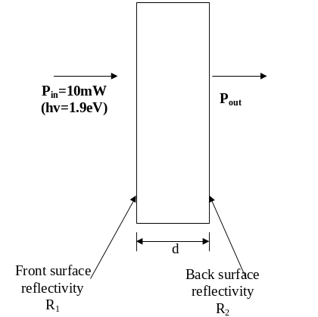 | 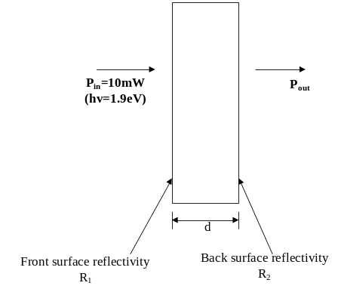 | 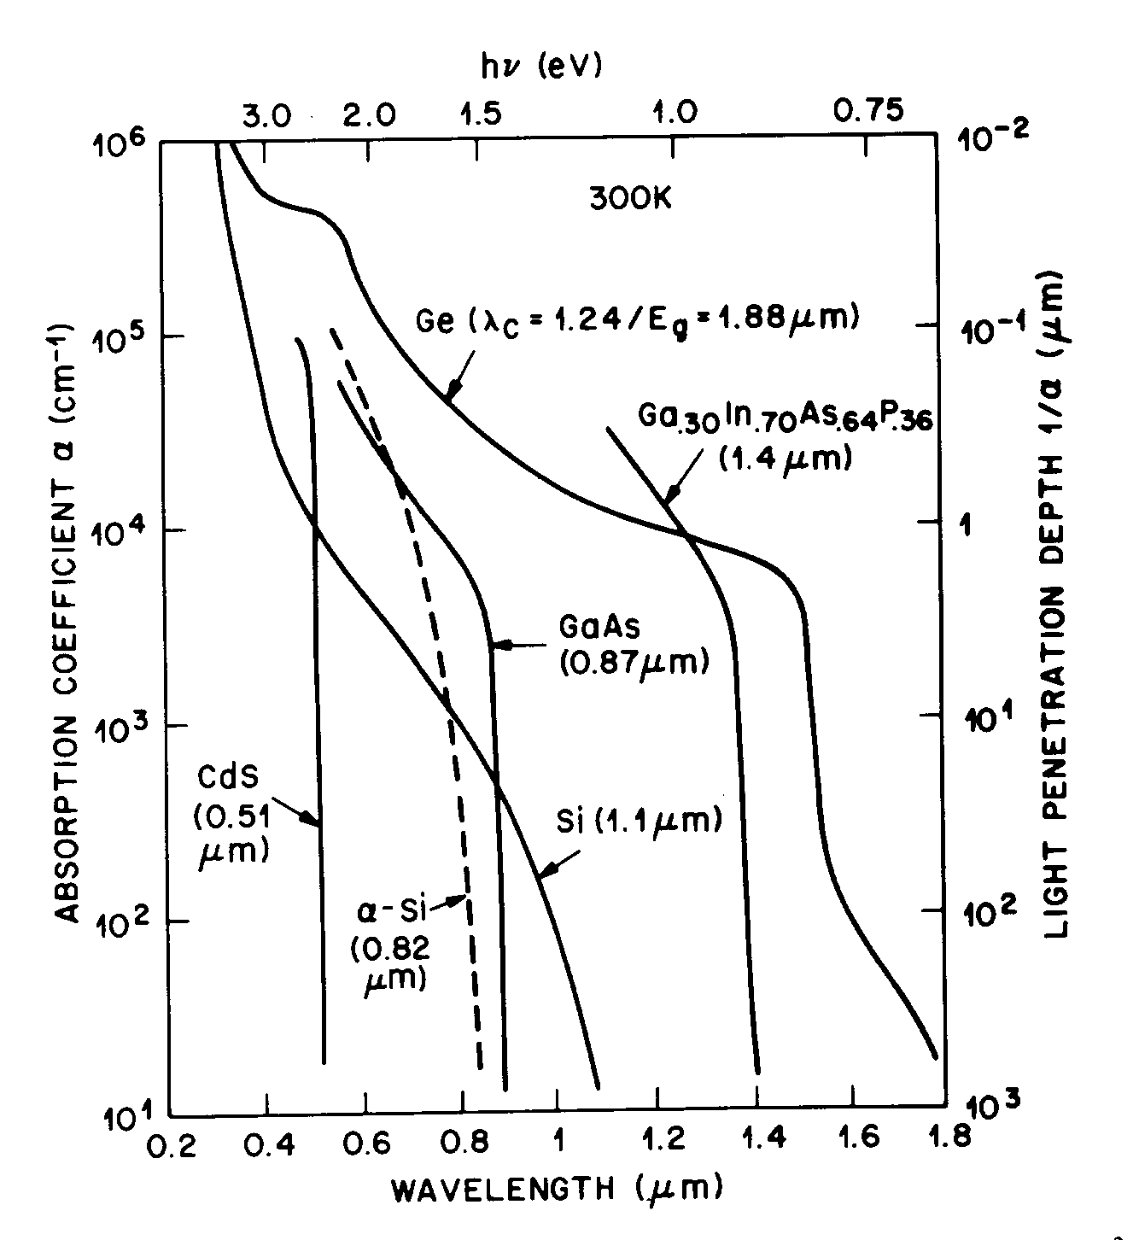
Fig. 1a Photon absorption in Si. | Fig. 1b Photon absorption in GaAs. | Fig. 1c Absorption coefficient vs l.
(a) Given the absorption coefficient α(hν=1.9eV of λ =0.65 μm) = 3000 cm⁻¹ in crystalline Si and index of refraction n_{r}=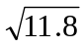≈3.45, find the power absorbed in Si in one pass.

(b) If the crystalline Si is replaced by amorphous Si (a-Si), find the absorbed power in film of 1 μm in thickness. Given α (hν=1.9eV of λ =0.65 μm) = 10,000 cm⁻¹ in a-Si sample. Assume the same index of refraction.

(c) Find the power absorbed in In_{x}Ga_{1-x}As_{y}P_{1-y} with x =0.7 and y=0.54 Use the plot of absorption coefficient in Fig. 1c. For index of refraction, use expression given in laser design. Index = (ε)^{1/2}.

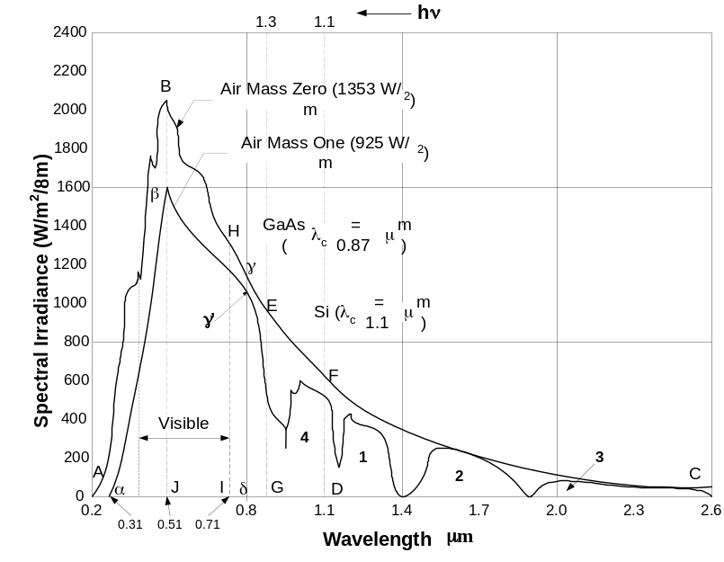
Fig. 2. Solar spectrum under AM O (m=0) and AM1. See Figs. 37 and 78 (Notes pages 448 and 449). The incident power received is 1353 W/m2 for AM=0 and 925 W/m2 for AM=1.

Q.2. Fig. 2. Shows the solar spectrum under AM 0 (m=0) and AM1 (m=1) conditions. . See Figs. 37 and 38 (Notes pages 448 and 449). The incident power received is 1353 W/m² for AM=0 and 925 W/m² for AM=1.

(a) The solar spectral range which is absorbed by an amorphous Si cell under AM1 condition assuming the band gap of amorphous Si to be 1.55eV. Circle one

triangle αβJ trapezoid βJ γ' δ triangle αβJ and trapezoid βJ γ' δ

(b) Show that the combined power in triangle αβJ and trapezoid βJ γ' δ is ~537W/m2.

(c) If the incident power in the spectral range of triangle αβJ is 160 W/m² and in trapezoid βJ γ' δ is 377 W/m², show that the power absorbed from this spectrum is 148.16 W/m2 in a 0.5 micron thick amorphous Si cell with absorption coefficient to be 10,000cm⁻¹.

(d) Show that the excess energy loss in trapezoid Jβ γ' δ (between wavelengths 0.8 and 0.51 μm) is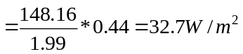. Here, 148.16 is the power absorbed.

(e) What is the short circuit current generated in the amorphous cell due to trapezoid Jβ γ' δ .

Q.3 Show that the long wavelength loss is 176.86 W/m2, in a crystalline Si cell under Air Mass m = 1 condition. HINT: sum of areas above λ >(1.24/1.1) ! 1.1 micron. Use Fig. 2.

Q.4(a) Show the polarity of output voltage and direction of current in load R_{L} of all solar cells in Fig. 3.
(b). Order these cells in terms of conversion efficiency, providing qualitative explanation.
(c) Which of the cells shown in Fig. 3 would produce the maximum power output P_{mp}.
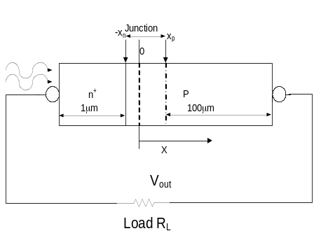  (a) | 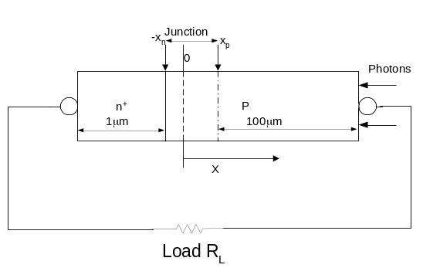  (b)
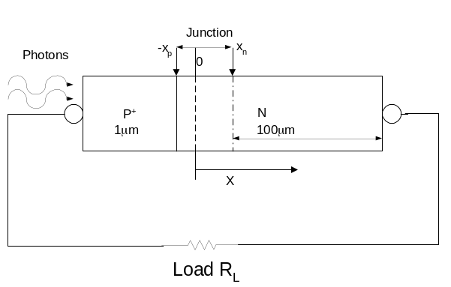  (C) | 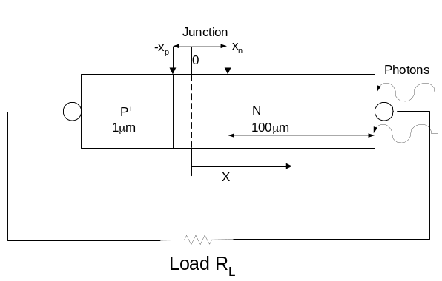 (d)
Fig .3. n+-p and p+-n Si solar cells illuminated from front and back.

Q5. Fig 4 shows an n⁺-p Si diode with following device/material parameters.
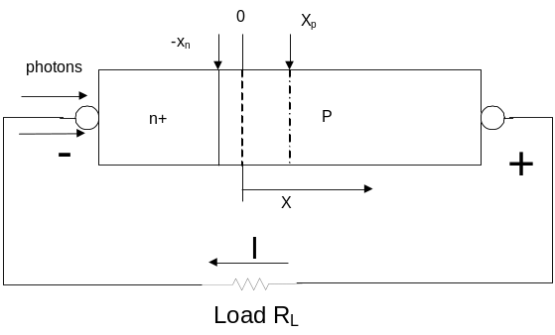
Fig. 4. An abrupt n⁺-p Si solar cell (the light is incident from the left or n+ side).
Given: n⁺-side: Donor concentration N_{D}=10²⁰ cm⁻³, minority hole lifetime τ_{p}=2x10⁻⁶ sec.
Minority hole diffusion coefficient D_{p}=12.5 cm²/sec.
p-side: Acceptor concentration N_{A}=5x10¹⁷cm⁻³, τ_{n}=10⁻⁵sec. D_{n}=40 cm²/sec.
Junction area A=1 cm², n_{I} (at 300K)=1.5x10¹⁰cm⁻³, ε_{r} (Si)=11.8, ε₀=8.85x10⁻¹⁴ F/cm, ε=ε₀ε_{r}.
Effective mass: electrons m_{e}=m_{n}=0.26m_{o}, holes m_{h}=m_{p}= 0.64 m_{o},
Assume all donors and acceptors to be ionized at T=300K.
- Find reverse saturation current I_{s}.

- Determine the open circuit voltage V_{oc}, if the light generated current I_{SC}= I_{L} = 27mA= the short circuit current.

- Determine the maximum output power P_{mp} or P_{m} =V_{m}*I_{m}.

- Find the fill factor FF.

- What is the effect on V_{oc} and fill factor FF if the doping of p-Si is raised to 10¹⁸cm⁻³.
V_{oc} will increase or Decrease
FF will increase or Decrease

- What happens to power output if the operating temperature is raised from 300K to 500K?
Circle one: Increases OR Decreases.

Q.6.(a) What does I_{sc} and V_{oc} primarily depend on: Circle the right answers
Band gap doping levels thickness of the n-region in a p-n cell incident solar power

Q6(b). Label I_{SC}, V_{DC}, maximum power point P_{m} in solar cell characterization. P_{m}=V_{m}*I_{m}

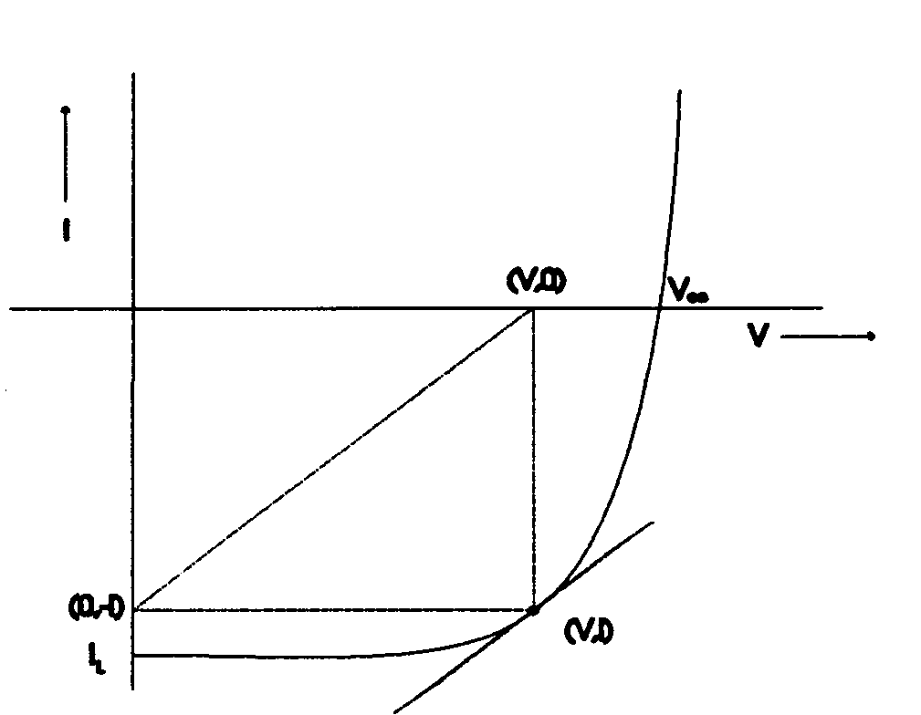Fig. 5

Q6(c). Solar energy is highest at following air mass m. Circle all that apply.

m=0 m=2 m=1 m=1.5

Q7 (a) Average solar power received during a day is. Circle one

74mW/cm² 104mW/cm² 130mW/cm²

Q7(b). How many photons/s are needed to deliver 1mW of power at the wavelength of λ=0.5 μm or photon energy of 2.48eV. Given photon energy hν=1.24/0.5μm = 2.48eV. Circle one

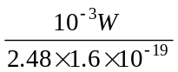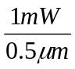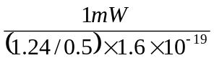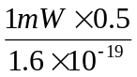

Q7(c). If you want to power your house with sunlight and need 10kW electrical power, how many panels N are needed? Assume average solar power is 740W/m²; panel size 1m x 1m, and conversion efficiency of panel is 12%.



