# **ECE 4211 Solution HW#8 LASER-II Design SET-Pass I** 03312017 **F. Jain.**

# Second pass will give chance to improve the score. **Take Home part I Quiz 2**

Q.1. Find the composition of the active layer/barrier layer/cladding layers for the 1.32 micron laser configured as a single mode laser using InGaAsP-InP system and producing 1.5 mW output power. The design of 1.35micron laser is described on pages 398-407 in Notes.

**Given**: Use hm = Eg + kT/4 to find Eg of the active layer in a double heterostructure (DH) laser without quantum wells or quantum dots. **Be quantitative where possible**.

⇒**Q1 a). Outline all the design steps**

Solution: Design steps: 1) Selection of Active layer, substrate and cladding layers, 2) Doping level of Active/cladding layers, 3) Active layer thickness ‘d’ for a transverse mode and stripe width ‘W’ for a single lateral mode, 4) Confinement factor (Γ), 5)Calculation of threshold current density (Jth), 6) Find the operating current, Iop and voltage, Vop that would provide 1.5mW of laser output, and 7) Computation of mode separation Δλ, frequency separation Δ beam divergence in the junction plane and perpendicular to the junction plane 

**⇒b1). Find the composition of the active layer and cladding layers, and**

**⇒b2) find their doping concentrations.** Active layer doping is given = 1016 cm-3.

b1) Solution of active and cladding layer compositions:

Active layer band gap: hm = 0.9393 = Eg + kT/4;

**Active layer band gap Eg = Eg2 (Point A)** = 0.9392 – 0.0259/4 = 0.9329eV. We need to find the composition of point A. We know the composition of point B to be In0.53 Ga0.37As and its band gap Eg1 to be 0.7eV. InP gap is 1.34eV. We solve for indium and phosphorus compositions below.

$In=0.53+0.47*(\frac{0.9329-0.7}{1.34-0.7})$ = 0.53 + 0.47 * 0.3639 = 0.701 ~ 0.70. $P=1*(\frac{0.9329-0.7}{1.34-0.7})$ = 0.36.

Composition of active layer with band gap of Eg2= 0.9329eV is **In0.7Ga0.30As0.64P0.36**

Since we calculated in class In and P to be In0.68 & P0.35, we will use theactive layer composition to be In0.68Ga0.32As0.65P0.35.

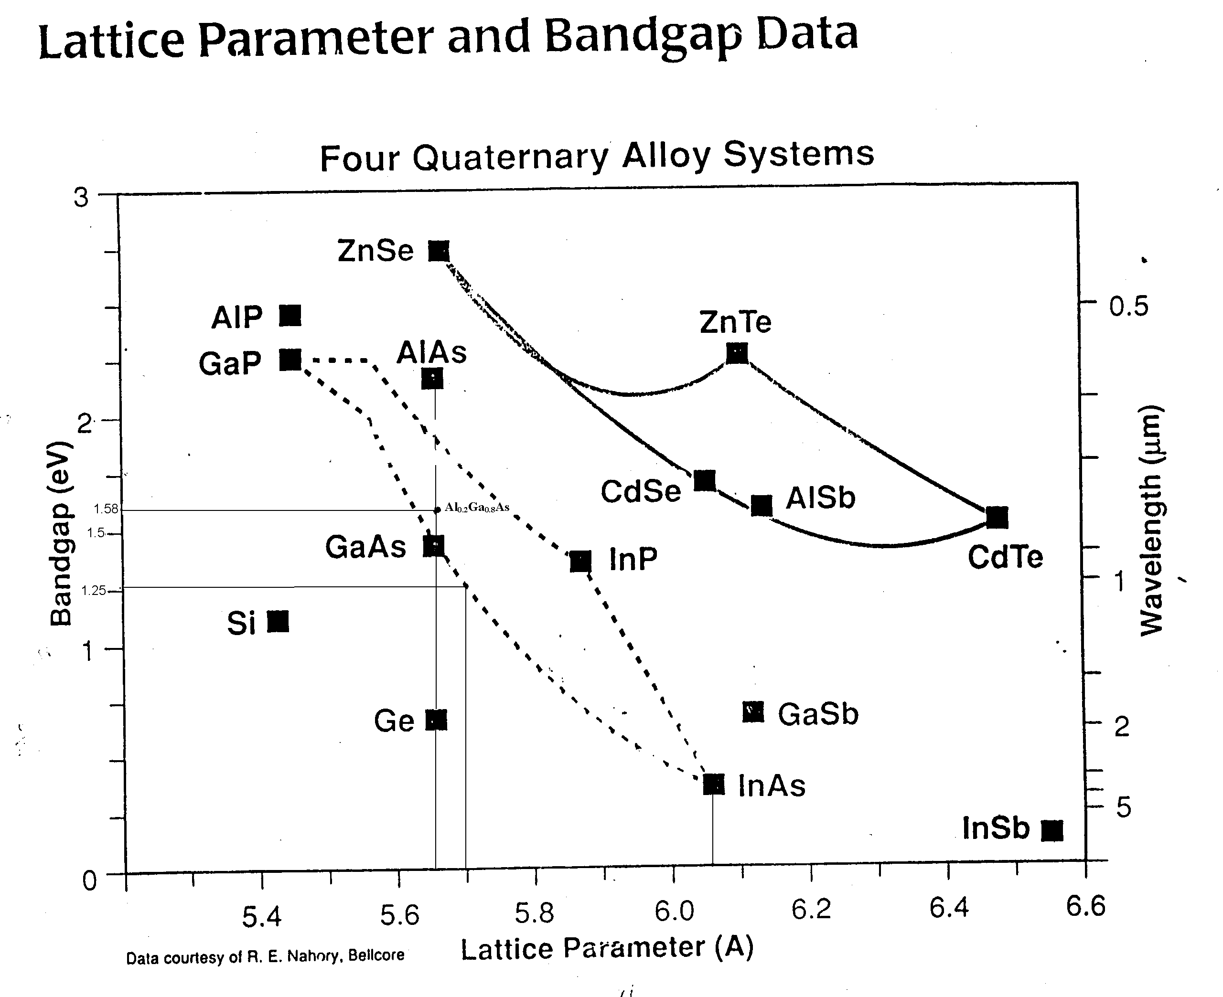

Clad for quantum dot laser D, Pt II

0.9239eV Eg2 active (A)

1.136eV Eg3 Clad (C)

C

A

D

B

0.70 Eg1 (B)

**Composition of cladding layer represented by point C.**

The cladding layer energy band gap is 0.2 to 0.5 eV higher to get sufficient energy band offsets EC and Ev to confine electrons and holes in the active layer. That is,

Eg,clad - Eg,active =0.2 to 0.5eV

For simplicity if we take cladding layer composition is halfway between active layer (point B) and InP, we get point C to be higher by about 0.2eV above of active layer band gap of 0.9329eV.

Thus, energy gap of cladding layer Eg3 =0.9329 + (1.34 -0.9329)/2 = 0.9329 + 0.4071/2=1.136 eV.

= In(0.68+0.32/2)Ga(1-In)As(1-P)P(0.35+0.65/2)

= In0.84Ga0.16As0.325P0.675

Cladding layer (Point C) composition is In0.84Ga0.16As0.325P0.675.

b2) From Bernard-Douraffourg condition,

Efn- Efp ≥ h ≥ Eg

, , here we do not know the quasi Fermil level. So we approximate by band gap of active layer Eg. Since Eg < (Efn –Efp) we use the ‘> ‘ sign..

To find ni of the active layer, we use the approximation given in design sets worked out in Notes.

$\frac{n_{i} (for {In}_{0.68}{Ga}_{0.32}{As}_{0.65}P_{0.35})}{n_{i} ( for GaAs)}=\frac{e^{{-0.9329}/{2kT}}}{e^{{-1.43}/{2kT}}}$; we know the value of = 107 cm-3

⇒ ni (Active layer) = 107 * e(1.43-0.9329)/2kT = 107 * e(0.4971/2*0.0259) = 1.471*1011 cm-3

⇒ ne >1.471*1011 * e(0.9329/2*0.0259) > 9.752 * 1018 cm-3;

Cladding layers doping is greater than = 9.752 * 1018 cm-3

⇒ c1) Find device dimensions (active layer thickness d, cavity length L and width W) to obtain single transverse mode and single lateral mode operation?

Sol: For single transverse mode, d < m /[2(nr2-nr12)1/2].

We need to find index of refraction for active and cladding layers.

We use

For active layer, x=0.68; 1-x=0.32; y=0.65; 1-y=0.35;

= 3.51018

For cladding layer, x=0.84; y=0.325; 1-x=0.16; 1-y=0.675

= 3.45477

The active layer thickness d should be less than (here we use m=1 so that only fundamental even mode is there).

d < m /[2(nr2-nr12)1/2], d < 1* 1.32*10-4/[2(3.510182-3.454772)1/2] or d < 1.0624 *10-4 cm

We choose d=0.2µm as it satisfies the condition d < 1.062µm.

The selection of d determines the threshold current density JTH.

The evaluation of stripe width W for a single lateral mode.

W < m /[2(nr,center2-nr,corner 2)1/2

We are provided with the index difference nr between the center of active layer and corner of active layer to be 0.005. The nr,center =3.51018, nr,corner = (3.51018 – 0.005) = 3.50518

m=1, W < 1*1.32*10-4/[2(3.510182-3.505182)1/2] ⇒ W < 3.523*10-4 cm ⇒ W < 3.523μm

So, we choose W = 3 μm

### d) Find the confinement factor. Use Following Equation forΓ: ,  is the free space wavelength.

Or Find the confinement factor Γ using , where .

Sol: For d=0.2µm,

 = = 0.17488,

⇒e) Find threshold current density and show that it is under **200 A/cm2**; explain if it is not.

Sol:

α=20cm-1; = 0.17488; ηq=0.9; Δνs=1.2*1012; z(T)=0.5; R1=R2=0.3

We take cavity length L=500µm;

$$J_{th}= \frac{8π*{3.51018}_{}^{2}*1.6*{10}^{-19}*0.2*{10}^{-4}*1.2*{10}^{12}}{0.17488*0.9*0.5}\left(\frac{1}{{\left(1.32*{10}^{-4}\right)}^{2}}\right)*$$

$$[20+\frac{1}{2*500*{10}^{-4}}*ln\left(\frac{1}{0.3*0.3}\right)]$$

$= \frac{1.1891*{10}^{-9}}{0.078696*\left({1.32}^{2}*{10}^{-8}\right)}\left(20+\frac{1}{0.1}\ln\left(\frac{1}{0.09}\right)\right) = 0.8676*(20+24.079)$ = 38.24 A/cm2

For L=200 µm,

Jth = 0.8676*(20+) = 69.58 A/cm2

⇒f) Analyze the designed structure and evaluate various parameters such as mode separation  and   

Sol:

= + 4.962*10-8 (1-0.564)-1 = 11.38*10-8 = 11.38 ºA

= 3.0*1010 () = 195.93GHz

⇒g). Find the beam divergence in the junction plane and perpendicular to the junction plane   

 = λ/w =1.32µm/3.0µm = 0.44*180/π = 25.22º

   radians

⇒h). Find operating current Iop and voltage Vop required for obtaining 1.5 mW laser output power.

For L=500 µm; Jth­ = 120.09A/m2; W=3 µm

Ith = W * L * Jth = 3*10-4*500*10-4*38.2346 = 0.5735mA; ηint = ηq * ηinj ≈ 0.9

For 1.5mW Power output = ;

1.5*10-3 =

⇒I=0.5735*10-3+((1.5*10-3*44.079)/(0.9393*0.9*24.079))

=0.5735*10-3+ 3.24*10-3 =3.8135mA

-1);

= = 7.07*10-4 cm; A = W * L = 30*10-4 = 900*10-8 cm2

= (1.471*1011)2/1016 = 2.16*1016

= 2.19*10-13 = 0.219pA

= 0.0259*ln(3.8135*10-3/0.219*10-12) = 0.6107V.