**UConn ECE 4211 Solution Set 9 Solar Cells F. Jain 03312017**

Q1 Figure 1 shows two 5 μm thick Si and GaAs samples illuminated by a 10 mW photon source. Assume the source to be monochromatic and emitting photons with energy hν=1.9 eV.

Q1(a) Given the absorption coefficient α(h=1.9eV of  =0.65 m) = 3000 cm-1 in crystalline Si and index of refraction nr=≈3.45, find the power absorbed in Si in one pass.

**Q1 (a)** R1 = R2 =

nr = = 3.4351

R1 = R2 = = 0.30146

Power entering in Si Pin’(X=0) = Power incident – power reflected

Or Pin’(X=0) = Pin - Pin * R1 = Pin (1 - R1) = Pin (1-0.30146) = 10mW * 0.699= 6.99mW

Power at X=d (5 m) = Pout = Pin*[exp (-αd)] = 6.99 mW*exp (-3000*5*10-4)

= 1.5596 mW

Power absorbed = Pin’ – Pout’ = Pabs1 = 6.99 – 1.5596 = 5.4304 mW ≈ 5.43 mW.

|  |  |  |
| --- | --- | --- |
|  |  |  |
| Fig. 1a Photon absorption in Si. | Fig. 1b Photon absorption in GaAs. | Fig. 1c Absorption coefficient vs  |

(b) If the crystalline Si is replaced by amorphous Si (a-Si), find the absorbed power in film of 1.0 m in thickness. Given α (h=1.9eV or  =0.65 m) = 10,000 cm-1 in amorphous a-Si sample. Assume the same index of refraction.

**Q1 (b)** Crystalline Si is replaced with amorphous Si (a-Si) in part (a)

So, R1 = R2 = 0.303

Power inside the a-Si wafer = Pin’(X=0) = Pin - Pin * R1

= Pin (1 - R1)

= Pin (1-0.301)

= 10mW * 0.699= 6.99mW

Power reading at X=d = Pout’ = Pin’[exp (-αd)]

= 6.99 mW*exp (-10000*1*10-4)

= 2.57 mW

Power absorbed = Pin’ – Pout’ = Pabs1 = 6.99 – 2.57 = 4.42mW.

Q1(c) Find the power absorbed in InxGa1-xAsyP1-y with x =0.7 and y=0.54 Use the plot of absorption coefficient in Fig. 1c. For index of refraction, use expression given in laser design. Index = (

**Q.1 c)** Find the power absorbed in InxGa1-xAsyP1-y with x =0.7 and y=0.54. Use the plot of absorption coefficient in Fig. 1c. For index of refraction, use expression given in laser design.

Index is expressed as nr = 3.52xy+3.39x(1-y)+3.60y(1-x)+3.56(1-x)(1-y)

= 3.52*0.7*0.54+3.39*0.7*(1-0.54)+3.6*0.54*(1-0.7)+3.56*(1-0.7)*(1-0.54)

= 1.3305+1.0915+0.5832+0.4912 = 3.4964

Find the power absorbed in In0.7Ga0.3As0.54P0.46

The reflection coefficient R = ${\left(\frac{n_{r}-1}{n_{r}+1}\right)}^{2}$ = ${\left(\frac{3.4964-1}{3.4964+1}\right)}^{2}$ = 0.308

Power entering InGaAsP is Power incident – reflected power = Pin’(X=0) = Pin – Pin*R1

= Pin (1-R1)

= Pin (1-0.308) = 10mW*0.69 = 6.92 mw

From α versus Eg  plot (Fig. 1c), the α( heV) for InGaAsP = 5*105 cm-1

Power output at X=d = Pout’ = Pin’[exp (-αd)], here d is 1 micron (1x10-4cm)

Pout’= 6.92mW*exp (-500000*1*10-4) = 6.77mW*e-50= 13.34*10-22W ~ 0 mW

Power absorbed = Pin’ – Pout’ = Pabs1 = 6.92 – 13.34*10-22~6.92 mW.



Fig. 2. Solar spectrum under AM O (m=0) and AM1. See Figs. 37 and 78 (Notes pages 448 and 449). The incident power received is 1353 W/m2 for AM=0 and 925 W/m2 for AM=1.

Q.2. Fig. 2. Shows the solar spectrum under AM 0 (m=0) and AM1 (m=1) conditions. . See Figs. 37 and 38 (Notes pages 448 and 449). The incident power received is 1353 W/m2 for AM=0 and 925 W/m2 for AM=1.

(a) The solar spectral range which is absorbed by an amorphous Si cell under AM1 condition assuming the band gap of amorphous Si to be 1.55eV. **Circle one**

triangle J trapezoid J ’  triangle J and trapezoid J ' 

Q2 (b) Show that the combined power in triangle J and trapezoid J '  is ~537W/m2.

The band gap of amorphous Si to be 1.55eV. The incident power is represented by a triangle J and a trapezoid J  '  The power at  is 1600W/m2 and at ' is 1000 W/m2.

Power in triangle J=

Power in trapezoid J '  



Power incident is 

Q2(c) If the incident power in the spectral range of triangle J is 160 W/m2 and in trapezoid J '  is 377 W/m2, show that the power absorbed from this spectrum is 148.16 W/m2 in a 0.5 micron thick amorphous Si cell with absorption coefficient to be 10,000cm-1.





Power absorbed by the a-Si in spectral regime of triangle  and trapezoid = 62.88+148.161= 211.041 W/m2

(d) Show that the excess energy loss in trapezoid J '   between wavelengths 0.8 and 0.51 m) is. Here, 148.16 is the power absorbed.

The average energy of photon in trapezoid is 1.99eV. This is shown below.

The average photon energy in the trapezoid between wavelengths 0.8 and 0.51 micron is

.

The excess energy per photon is 1.99-1.55= 0.44eV. Excess energy is number of photon/s times average energy lost. It is 

(e) What is the short circuit current generated in the amorphous cell due to trapezoid J '  

Short circuit current is power absorbed divided by average photon energy and multiplied by q.

119.12 A for a panel of 1 m2. In terms of area of 1cm2, the ISC = 11.9mA.

Q.3 Show that the long wavelength loss is 176.86 W/m2, in a crystalline Si cell under Air Mass m = 1 condition. HINT: sum of areas above  > (1.24/1.1)  1.1 micron. Use Fig. 2.

**Solution:**

(a) Long wavelength losses for AM1

With reference to the above figure, in area of region 1, 2 & 3, the solar power is:

Region #1 = 0.5*456*0.3 = 68.4 W/m2

Region #2 = 0.5*297.6*0.5 = 74.4W/m2

Region #3 = 51.5*0.7 = 36.05 W/m2

Total long wavelength photons loss = 68.4+72.69+35.77 = 176.86 W/m2

**OPTIONAL:** Calculate the excess energy lost in the spectral range represented by triangle J for AM1 in a crystalline Si.

The area of triangle J = [1600*(0.51 – 0.31)]/2 = 160 W/m2.

The average photon energy hav in triangle J is

(1.24/0.31 + 1.24/0.51)/2 = (4.0 + 2.43)/2= 6.43/2 = 3.215 eV.

Excess energy per photon not used in creating electron-hole pairs in Si (Eg=1.1eV) is

3.215-1.1 = 2.115eV.

**Q.4(**a) Show the polarity of output voltage and direction of current in load RL of all solar cells in Fig. 3.

**Solution: (a) Voltage polarity and current directions are shown below.**

|  |  |
| --- | --- |
| (a) | (b) |
| (C) | (d) |

Q4(b) η(a) > η(c) > η(b) > η(d) (Efficiency of the cells in the order).

Q4( c ) Cell (a) has maximum output.

**Q5.** Fig. 2 shows an n+-P Si diode with following device / material parameters.



Fig. 2. An abrupt n+-p Si solar cell (the light is from the left or n+ side)

Given: **n+-side:** Donor concentration ND = 1020 cm-3, minority hole lifetime τp=2x10-6 sec. Minority hole diffusion coefficient Dp=12.5cm2/sec.

**p-side:** Acceptor concentration NA=5x1017 cm-3, τn=10-5 sec. Dn=40cm2/sec.

Junction Area = A = 1 cm-2, ni (at 300K)=1.5x1010cm-3, εr (Si)= 11.8, ε0=8.85x10-14F/cm, ε=εrε0. Effective mass: electrons me=mn=0.26mo, holes mh=mp= 0.64 mo,

Assume all donors and acceptors to be ionized at T=300K.

1. Find the reverse saturation current Is

Reverse saturation current = 

np0 = 

pn0 = 

Ln = 

Lp = 

Is = , neglect the second term as it is smaller than first.

Is = 0.145 pA.

1. Determine the open circuit voltage Voc, if the light generated current IL = 27mA. Assume IL=ISC (the short circuit current). ***Find Is value like HW#2 solution set. This is n-p diode.***
2. Determine the maximum output power Pmp.
3. Find the fill factor FF.
4. What is the effect on Voc of raising the operating temperature from 300K to 500K.

# Solution Q5(b)



Open circuit voltage at 300K,



**Solution 5(c)**

Pm = VmIm



Fig. P4. Im-Vm point shown on the solar characteristics (curve is not joined smoothly).



 (A)

Find Vm: Write a program or do by trial & error.

Vm = 0.59V makes both LHS & RHS almost the same.

Get Im by substituting in Vm in I-V equation.







**Q5(d) solution**

Fill Factor (FF) = 

**Q5 (e) Solution**

Voc Increase

FF Increase

**Q5 (f) Solution**

Power decreases as the temperature is raised.

**Q.6.** (a) What does Isc and Voc primarily depend on: **Circle the right answers**

**Isc depends on all:** band gap, doping levels, thickness of the n-region in a p-n cell

A nd solar power incident on cell.

**Voc depends on all four factors listed.**

Q6(b). Label ISC, VOC, maximum power point Pm in solar cell characterization. Pm=Vm*Im

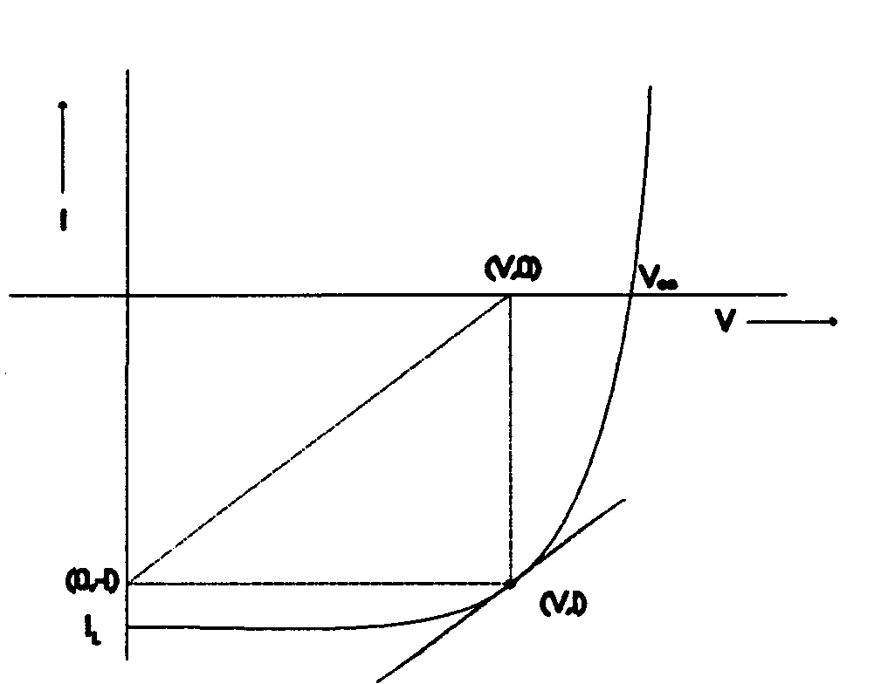Fig. 5

VOC

ISC

Im Vm

Q6(c) . Solar energy is highest at following air mass m. **Circle all that apply.**

m=0 m=2 m=1 m=1.5

Q7(a) Average solar power received during a day is. **Circle one**

74mW/cm2 104mW/cm2 130mW/cm2

Q. 7 (b) How many photons/s are needed to deliver 1mW of power at the wavelength of =0.5 m or photon energy of 2.48eV. Given photon energy h=1.24/0.5m = 2.48eV. **Circle one**

   

Q 7(c). If you want to power your house with sunlight and need 10kW electrical power, how many panels N are needed? Assume average solar power is 740W/m2; panel size 1m x 1m, and conversion efficiency of panel is 12%.

 