ECE4211 HW#10R Solar Design-Pass I 03/30/2017 due 04/6/17 F. Jain
Q. 1. Design an n+-p Si solar cell for air mass m=1 (AM1). Assume that the incident radiation for AM1 (Fig. 1) is 92.5mW/cm². I_{L}=I_{SC} = 38.97mA/cm².
Follow cell design example of Section 6.12, page 511-518.
Given: p-Si crystalline wafer with doping of 8x10¹⁶cm⁻³.
n⁺-side: Donor concentration N_{D}=10²⁰ cm⁻³, minority hole lifetime τ_{p}=2x10⁻⁶ sec.
Minority hole diffusion coefficient D_{p}=12.5 cm²/sec.
p-side: Acceptor concentration N_{A}= 8x10¹⁶cm⁻³, τ_{n}=10⁻⁵sec. D_{n}=40 cm²/sec.
Junction area A=1 cm⁻², n_{i} (at 300K) = 1.5x10¹⁰cm⁻³, ε_{r} (Si)=11.8, ε₀=8.85x10⁻¹⁴ F/cm,
ε=ε₀ε_{r}. Assume all donors and acceptors to be ionized at T=300°K.
- Find the thickness and index of refraction of the AR coating material for 0.51 micron as the average of entire spectrum. Copy from the Design example.
Design Pass #2 Other approaches to AR coating: Surface texturing to prevent surface reflection? You may want to look at GaN LED structure (Fig. 33, p,. 316).
- List the criteria to select the thicknesses of n+ window and p-Si absorber layer. Follow Design Level-I Section 6.12.1 and Section 6.12.2.
- Determine the open circuit voltage, maximum power point P_{m} = V_{m} I_{m} and the fill factor (FF).
- Find dominant losses:
a) Long wavelength photons hν<E_{g}. Use value given in solved design.
b) Excess photon energy (hν-E_{g}) not used in generating electron-hole pairs. That is triangle αβJ, trapezoid J β γ’δ. and DF’γ’δ. Use value given in solved design for the triangle and the trapezoid. Calculate only the region DF’γ’δ.
c) Voltage factor.
d) Fill factor
- Plot all the losses as a bar chart, and .show after all the above losses that the cell could be over 20% efficient.
- How would you improve the efficiency of your current cell?
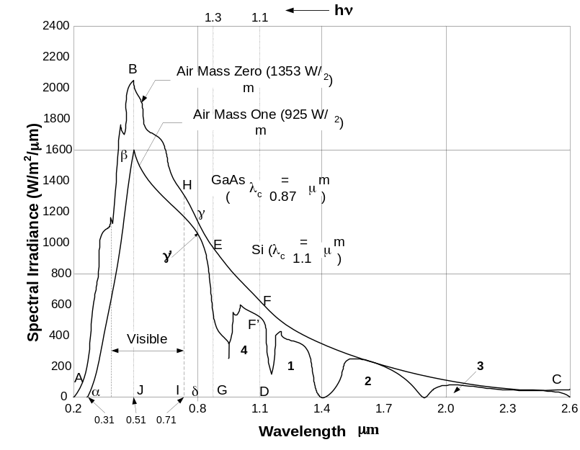
Fig.1 Solar spectrum at m=0 and m=1. Same as Popquiz
Solution Set:
Contact stripe
AR coating
n+-Si

Junction

p-Si

Back contact
N+-side p-side
For AM1 condition, the incident solar spectrum generates a short circuit current of 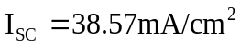 in a cell of 1cm² area.
(i) Surface reflection loss
Index of refraction of Si is 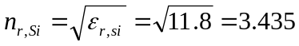
Reflectivity of Si=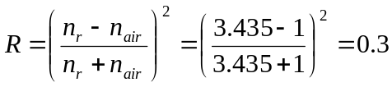
Reflection Loss=P_{in}*0.3=27.75mW/cm² for 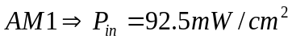 or 925W/m²
Antireflection Coatings (AR) can mitigate the reflection loss.
Solar spectrum is very broad. We design a coating of thickness ‘t’ with an index of refraction n_{r2} to eliminate reflection loss.
AR Coating
n_{r2}
t
n-Si= 0.5μm Junction

p-Si
d
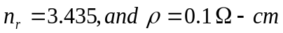

For N_{A}=2*10¹⁷cm⁻³, ρ = 0.1 Ohm-cm
Schematic of solar cell
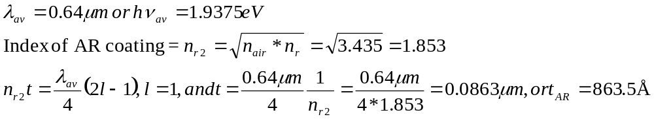
(ii) List the criteria to select the thicknesses of n+ window and p-Si absorber layer. Follow Design Level-I Section 6.12.1 and Section 6.12.2.
Criteria to determine the thickness of n+ Si window region include
(a) Voltage drop in n+ layer when electrons (generated in p-absorber layer are transported across the junction in n+ layer) is about 1-2% of V_{m}.
The only consideration is that series resistance R_{s} loss (voltage drop and power dissipation) is very small. That is Rs* I_{sc} < 0.05V. I_{L}=I_{SC} = 38.97mA/cm².
R_{s} < 0.05/38.97*10⁻³ or, R_{s} < 1.25 Ohm.
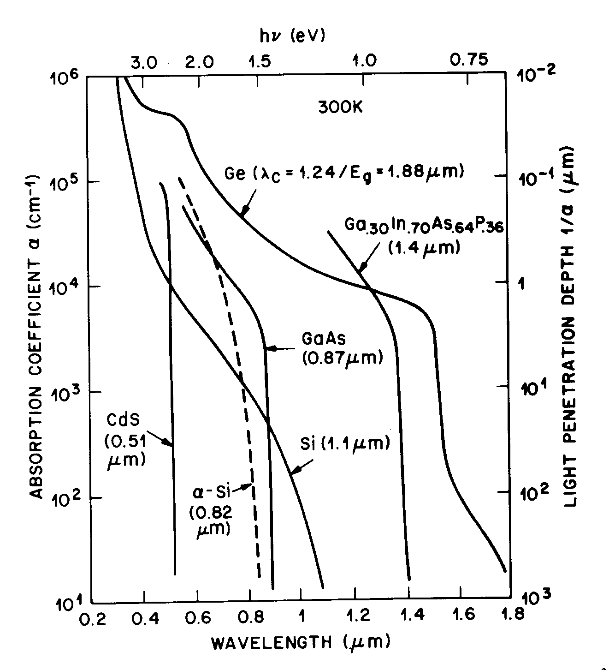
R_{s} is related on resistivity ρ of the n⁺ layer (which depends on the doping concentration N_{D}; for 10²⁰cm-3, it is 8x10⁻⁴ Ohm-cm) ) and it’s thickness t (unknown). Here, we are neglecting the drop across p-Si thick layer d with ρ=0.1 Ohm-cm). R_{s} = ρ∗L/(A), A is the area of cross-section (=t*cell length 1cm) and length L is the separation between top Ohmic contact lines. Here, t (n-Si) = ρL/R_{s} =0.1*8x10⁻⁴/(1) =0.8 microns. We have selected 0.5 microns which is true if the separation is less than 1mm.

(b) The power absorbed in n+ layer should be as small as possible, 5% or so.
P_{abs} (n+ layer of thickness t_{n}) = P_{in} [1- exp (-αt_{n})], if exponential term is 0.95, we have 5% absorption. That is, exp (-αt_{n}) = 0.95; taking natural log, -αt_{n} = ln(0.95) = -0.0512.
This gives t_{n} = 0.0512/α. The absorption coefficient α in Si varies as photon energy. If its value is ~1000cm⁻¹ in most dominate spectral region. t_{n} ~ 0.512*10⁻⁴cm.

Criteria to determine the thickness of p- Si absorber region include:
(c) The thickness of p-Si is determined by the absorption length of photons which is 2/α or 3/α where α is the absorption coefficient.
(d) Another criterion to determine the thickness d of p-Si is to keep it 2-3 diffusion length of minority electrons 2L_{n}-3L_{n}. L_{n} is 2x10⁻² cm so 2 L_{n} = 4x10-2cm or 400 microns. Thickness may be small using 2/α.

(iii) Determine the maximum power point V_{m}, I_{m}
V_{m} and Im are expressed as: .
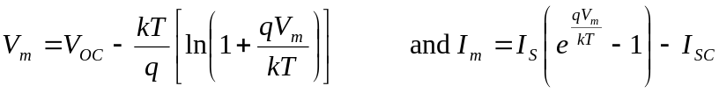
Here, 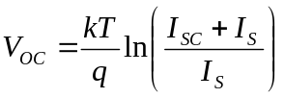.

We need to find V_{OC} to find V_{m}, and to find V_{OC} we need to find the reverse saturation current I_{s} as I_{SC} is given to be 38.97 mA.
I_{s} is expressed as
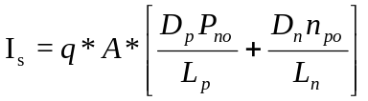
p-side: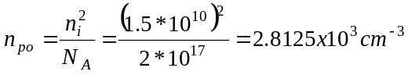, 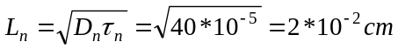

n⁺-side: (window region)
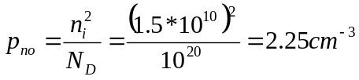 and
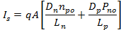
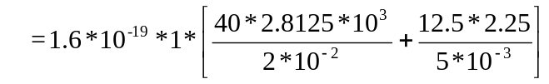
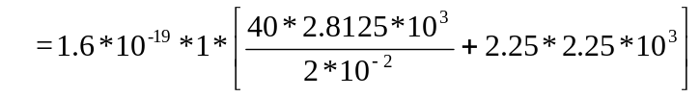=0.9*10⁻¹² +0.9*10⁻¹⁵ =0.9*10⁻¹²
I_{s} = 0.9*10⁻¹² A
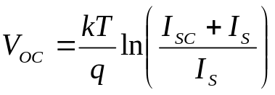
V_{oc} =0.0259 ln[(38.97x10⁻³ + 0.9x10⁻¹²)/ 0.9x10⁻¹²]
V_{OC} = 0.6343V
The maximum power point V_{m} and I_{m}

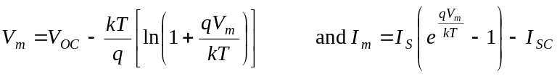
Substitute V_{OC} and kT/q = 0.0259V in 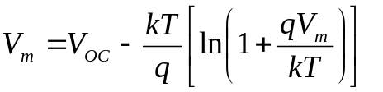
V_{m} =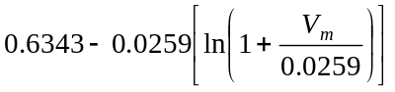. Since V_{m} is on both sides, we need to write a short program or do trial and error substitution. We know V_{m} is less than V_{OC}, so we guess it to be 0.5V. for this guess we tabulate Left Hand Side (LHS) and Right Hand Side (RHS) until the value of V_{m} makes both sides equal.
LHS RHS
0.5V (first guess) 0.5563
0.55 0.5539
0.554 0.5544
So V_{m} = 0.554V and I_{m} is obtained by substituting V_{m} in the current equation.

I_{m} = 0.9*10⁻¹²[exp(0.554/0.0259) -1] -38.97X10⁻³

=1.753x10⁻³ -38.97x10⁻³ = -37.217 mA

Maximum power P_{m} = V_{m}*I_{m} = 37.217*0.554 = 20.618 mW (for a cell of area 1 cm²).

Fill Factor FF = 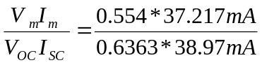=0.834
FF = 0.834

(iv) Compute dominant losses
(a) We now compute the long wavelength photons that are not absorbed. These are photons below the energy gap E_{g} = 1.1eV for Si. These are shown in the above Figure, in area of region 1, 2 & 3, and a triangle F’/1.1 (D) /1.16 (D’) micron point on x-axis.
The solar power in these regions is: Region #1=68.4 W/m², Region =2 72.69 W/m², and Region#3 = 35.77 W/m².These values have been calculated in solar design before.
Region #F’DD’ (in hint set triangle F’DK) power is 16.5 W/m², as shown below.
Total long wavelength photon loss is 193.36 W/m² or 19.36 mW/cm².
The % of long wavelength light loss at AM1 in Si = 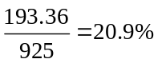.
The remaining power is 731.64 W/m².
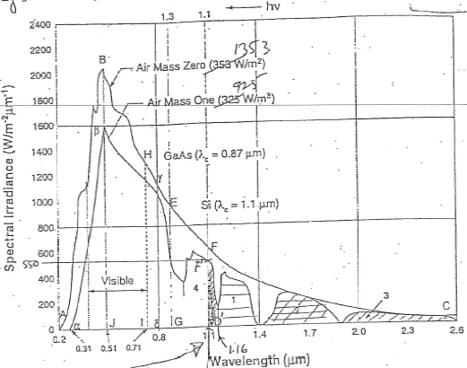
Two curves show solar spectral irradiance for AM1 and AM0.

(b) We next calculate the Excess Energy Loss for photons above E_{g} or 1.1eV which have more energy than needed to create an electron-hole pair.
Excess photon energy not utilized in electron hole pair generation 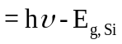
Let AM1 plot above 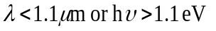is divided in several regions. The exact way is to find the area under the curve numerically. Regions are: Triangle , Trapezoid , Trapezoid marked as #4. These are calculated next.
Excess photon energy lost in spectral region represented by triangle
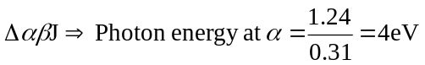 and 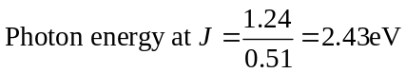
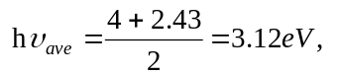
Area if the 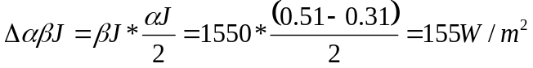
Excess energy not used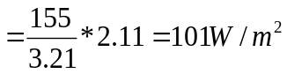
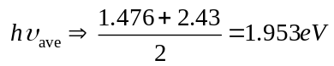
Excess energy lost
Trapezoid #4, Rectangle #5 & Rectangle #6 can be combined by a rectangle
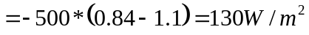
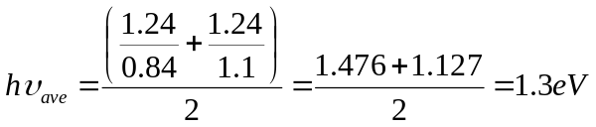
Excess energy =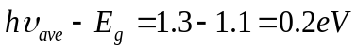
Excess energy not used =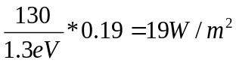
Total excess energy loss = 101 + 180.16 + 19 = 300.16 W/m².
The percentage loss is 300.16/925 = 32.4%.
Available power is 731.64 – 300.16 = 431.48 W/m².

(c) Voltage factor is defined as the ratio of V_{OC} and E_{g}/q.
Voltage factor 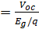=0.6343/1.1 = 0.5766.
The loss is 431.48 x (1-0.5766) = 182.68 W/m2.
The % loss is 182.68/925 = 19.74%.
This leaves available power of (431.48 – 182.68) = 248.80 W/m².

(d) Fill Factor (FF) is defined as (V_{m}I_{m})/(V_{OC} I_{SC}).
FF = 0.834
The power loss due to FF is (1-0.834)*248.80=41.30 W/m².
The % loss is 41.30/925 = 0.044=4.4%.
The remaining power is (248.80 – 41.30) = 207.50 W/m².
The remaining cell efficiency is 22.56%.
OPTIONAL: Collection efficiency of photo-generated electrons and holes. In crystalline Si this loss may be 10%. However, it is significant in poly-crystalline Si substrates, where it is ~20%.
A 10% loss reduces the available power to (207.5 – 20.75) = 186.75 W/m². The % loss in efficiency is 20.75/925 = 2.2%.
The remaining cell efficiency is 20.36%.
Series resistance loss: Series resistance loss R_{s} and other losses.

(v) Bar chart;
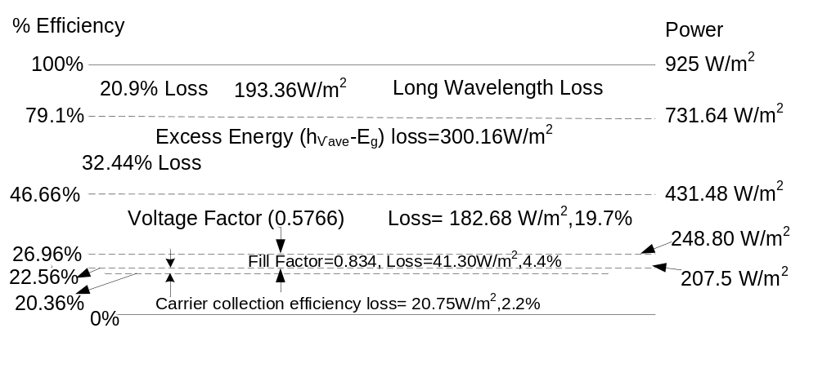Bar chart of losses in Si solar cell.
(vi) How would you improve the efficiency of your current cell?
The efficiency is given by η = (V_{m}*I_{m})/P_{in} = [(V_{m}*I_{m})/ V_{oc}*I_{SC} ] *[(V_{oc}*I_{SC})/P_{in}]
η = Fill Factor * [(V_{oc}*I_{SC})/P_{in}].
The efficiency can be increased by increasing fill factor, V_{oc} and Isc.
V_{oc} can be increased by reducing reverse saturation current.
I_{SC} can be improved by removing defects in the absorber layer where photogenerated electron hole pairs can recombine before separation across the p-n junction.
V_{oc} can be increased by tandem cells. But tandem cells reduce I_{SC} so a tradeoff is there.
Isc can be improved by having a lower energy gap absorber. But lower energy gap reduced V_{oc}, so there is a tradeoff.
Having a heterojunction cell whose window region is of larger energy gap reduces loss in window region.
Use of n+-n/p-p+ cell improves V_{oc} in both homojunction as well as heterojunction cells.

