ENGR-ECE4243-6243 **HW#5AR Quantum confined Stark Effect in** Quantum Wells, Optical Modulators using MQW structures, UCONN, 10/4/16 F. Jain, Due date to be announced.

Q.1 (a) Describe the operation of a MQW based electro-absorptive modulator (seeL5 PowerPoint Fig. on slide 1 by Wood et al. or Fig. 15 on slide 2 by Kan et al).

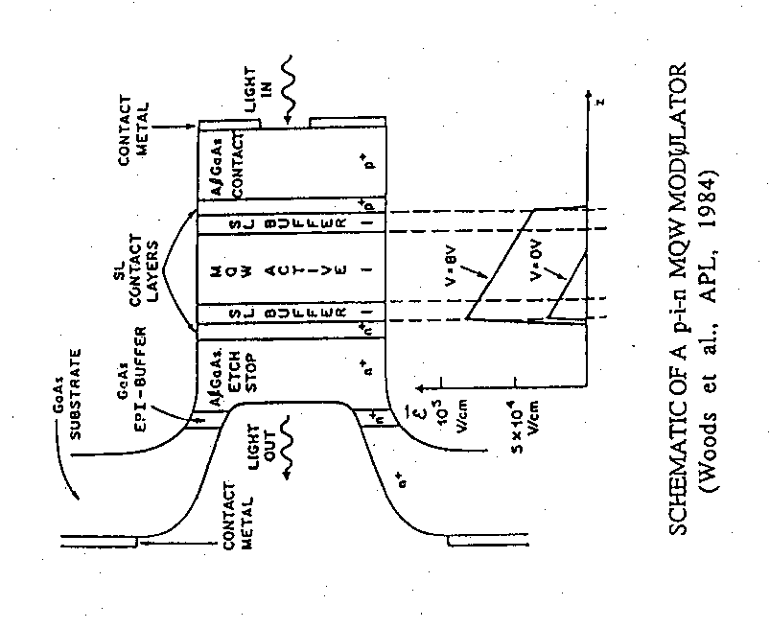

(b) Calculate change in power output due to change in absorption coefficient change as funciton of applied perpendicular electric field E⊥ when the field is changed from 0.4x105 V/cm [identified as (i)] to 1.2 x 105 V/cm (plot iii) of Kan et al figure below at an operating wavelength of 860nm. The GaAs well is 100Å and AlAs barrier is 200 Å. **Given:** (860nm)=10cm-1 at E⊥= 0.4x105 V/cm and (860nm)=4000 cm-1 at E⊥= 1.2 x 105 V/cm.

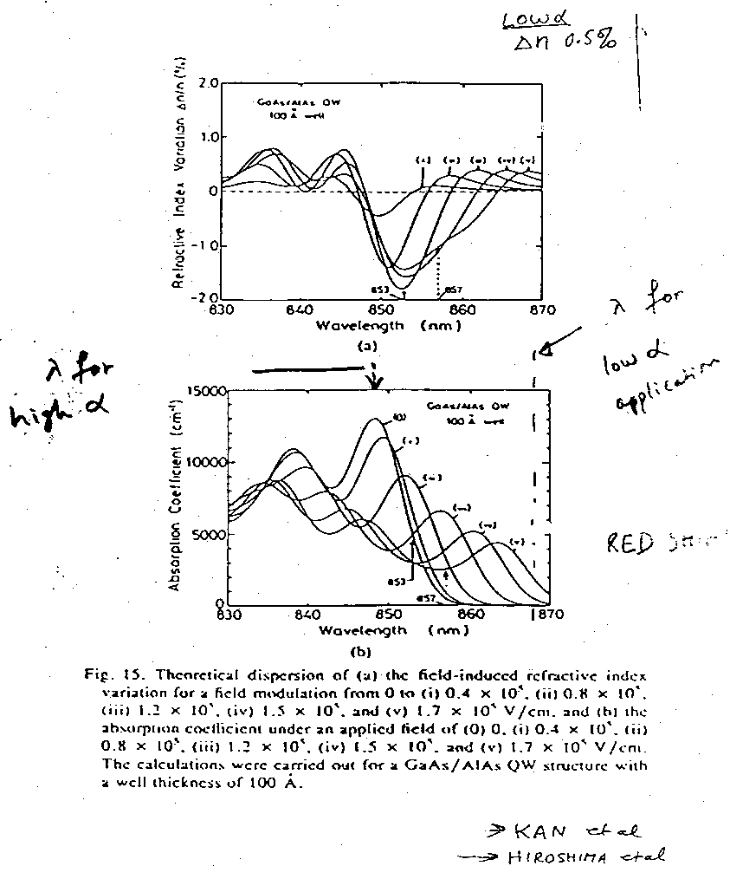

(c) How many quantum wells are needed to reduce the incident intensity by 50%. **SEE HW4B**

Q2. (a) How does a Fabry-Perot structure with cavity filled with MQWs enhance the change in % transmission as the electric field is applied across the cavity? See slide 3 and 4 (L5). Also see supplementary notes distributed today. See page 4 for Fabry-Perot info from Hinton’s Plenum reference. Use equation 4.3.116 and 4.3.14 and 4.3.3. Fabry Perot cavity transmission equations. Use angle of incidence to be zero or normal incidence.

Q 2(b) what happens to % transmission if the quantum well thickness is reduced from 51A InGaAs to 40A InGaAs while maintaining the cavity thickness same. Explain in terms of wavelength of operation.

Q.3(a) How does an index of refraction change n changes the phase of a light wave propagating in a waveguide. Given phase change  equation and index change values, what is the thickness of quantum wells to have a phase change of .

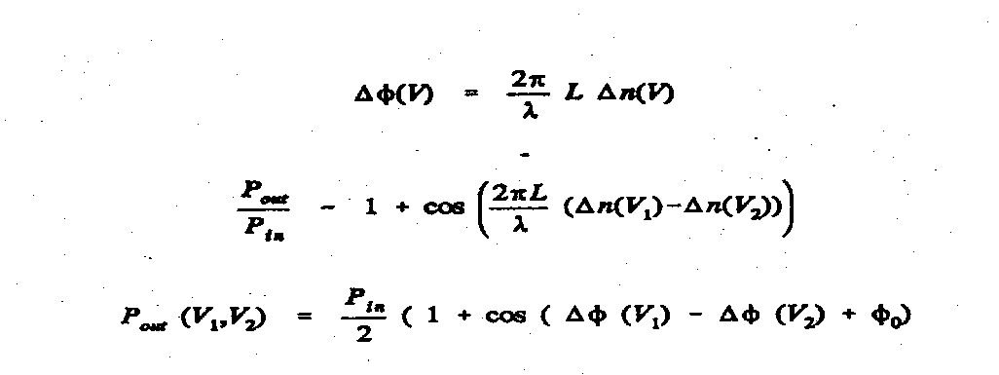

Q.3(b) Describe the operation of a Mach-Zehnder modulator using linear electro-optic effect in fibers or in LiNbO3 waveguide based devices. Figure below shows n for linear electro-optic (e.g. LiNbO3) and quadratic MQW waveguide layer.

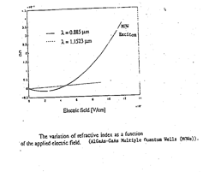

Q.3(c) If the output intensity Io equation as a funciton of phase change  is given below, find the ratio of Io/Iin for a MQW waveguide with GaAs quantum wells (like device of Q.1b operating at a field of 1.2 x 105 V/cm (plot iii of Kan).

Q.4 Calculate V value for MQW Mach-Zehnder modulator if the index of refraction change at E field of 1.2 x 105 V/cm. USE Kan et al index change values. Fig. for Q1b.

**Info for Q.2.** H. Scott Hinton, An Introduction to Photonic Switching Fabric, Plenum, 1993. Section 4.3.1 Fabry-Perot Etalon.

The cavity shown below is sandwiched between two mirrors M1 and M2 and has a thickness is d and comprising of multiple quantum well with an effective index of refraction nc. The incident wave electric filed Ei is reflected as Er1 depending on incident angle i and part of this is transmitted at an angle t. The phase shift between two adjacent reflected/transmitted waves is 



Here,  is the phase change at the interface (it is  for dielectric mirrors). As shown in handout during Lecture L6 (page 12 Fig. 1a and Laser Chapter in ECE 4211) the summation of all outputs gives field transmissivity t= Et/Ei. The intensity ratio is It/Ii = (Et/Ei )2 =t2. Similarly, as the intensity reflectivity coefficient R = r2. The summary of equations representing transmission and reflection coefficients are given below.

Transmission,,

Reflection , here 

|  |  |
| --- | --- |
|  | page 176 of Notes. |

When the light is incident normally i and t are zero. . The transmission is minimum if sin2/2 = 1. Or when  is , 3 or  = , 3 

For minimum  

For maximum, sin2/2 = 0,  is ,   and Tfpmax = 1. One can thus find the ratio.

The Fabry-Perot peak shifts when an Electric field E⊥ is applied across the multiple quantum wells as index nc value is changed (see Q1b). For a given wavelength 860nm =0.86 microns, using index change nc = 0.005 at two different E⊥values find the d change and corresponding intensity change.

ECE 4243-6243 10042016 L6: F. Jain HW6BR Modes in Optical Waveguides

Waveguide Equations for light waves: One dimensional confinement along x-axis.

Three slab waveguide structure. Waveguide thickness is d.

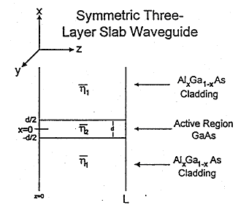

Waveguide equation is like Schrodinger equation for electrons. ko = 2/ o

5. 

Wave propagating in the z-direction

18. 

EVEN **TE** MODES: In waveguide the electric and magnetic fields are;

 , 

Outside waveguide or in cladding:: 



Solution to the Eigenvalue equation involves finding k and by solving eq. 38 and 39.

38.  and

Substitution(15),(23)

as  (equation 15)

and  (equation 23)

Add equations 15 and 23:

, multiplying by 



39. Rewriting Equation 27 as:

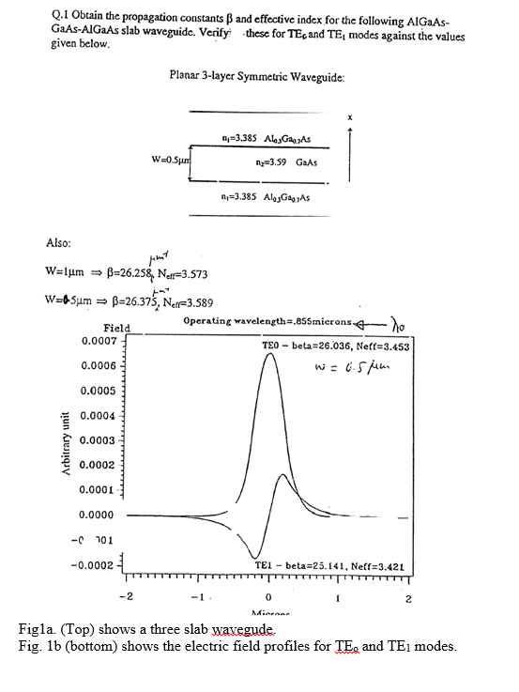

In this question, W is used in place of d.

The operating wavelength is o= 0.855 microns. ko = 2/ o

Note k is different than ko as shown in .