**ENGR_ECE4243-6243 Solar Cells HW12+Solutions F. Jain 11292016**

**This home work will be the basis of Popquiz 4 on 12/06/2016**

Q1 Figure 1 shows two 5 μm thick Si and GaAs samples illuminated by a 5 mW photon source. Assume the source to be monochromatic and emitting photons with energy hν=1.9 eV.

1. Given the absorption coefficient α(h=1.9eV of  =0.65 m) = 3000 cm-1 in crystalline Si and index of refraction nr=≈3.45, find the power absorbed in Si in one pass.

|  |  |  |
| --- | --- | --- |
|  |  |  |
| Fig. 1a Photon absorption in Si. | Fig. 1b Photon absorption in GaAs. | Fig. 1c Absorption coefficient vs  |

(b) If the crystalline Si is replaced by amorphous Si (a-Si), find the absorbed power in film of 1.0 m in thickness. Given α (h=1.9eV or  =0.65 m) = 10,000 cm-1 in amorphous a-Si sample. Assume the same index of refraction.

(c) Find the power absorbed in InxGa1-xAsyP1-y with x =0.7 and y=0.54 Use the plot of absorption coefficient in Fig. 1c. For index of refraction, use expression given in laser design. Index = (

(d) Find the excess energy per photon in c-Si, a-Si and InGaAsP. HINT: The excess energy is (h-Eg) per photon.

(e) Find out the portion of absorbed energy that is not used up in electron-hole pair (EHP) generation in crystalline Si and GaAs. **Hint:** It is wasted in the form of heat. Multiplying this by the number of photons will give the power that is wasted.

# Solution Q1

**Q1 (a)**

R1 = R2 =

nr = = 3.4351

R1 = R2 = = 0.30146

Power entering in Si Pin’(X=0) = Power incident – power reflected

Pin’(x=0) = Pin - Pin * R1 = Pin (1 - R1)

= Pin (1-0.30146) = 5mW * 0.699= 3.495mW

Power at x, P(x) = Pin’*[exp (-αx)]

Power at x=d (5 m) = Pout‘= Pin’*[exp (-αd)] = 3.495mW*exp (-3000*5*10-4) = 0.7798mW

Power absorbed = Pin’ – Pout’ = Pabs1 = 3.495 – 0.7798 = 2.7152 mW ≈ 2.715mW

**Optional: Power absorption in the event there is back refelction**

Some of the power that reaches x=d is reflected back and its value is

Pout’’ = Pout’ * R2 = 0.7798 mW * 0.301= 0.2347 mW

Of this, the fraction absorbed (in travel to surface R1= Pabs2 = Pout*(1-e-αd)

= 0.2347mW (1-e-1.5) = 0.182 mW

Pout’’ will be reflected from surface #1 (R1Pout’’) and some of this will be absorbed. But these magnitudes are smaller.

Total power absorbed in two passes= Pabs = Pabs1 + Pabs2

= 2.7152 + 0.182 = 2.8972 mW

**Q1 (b)**Crystalline Si is replaced with amorphous Si (a-Si) in part (a)

So, R1 = R2 = 0.303

Power inside the a-Si wafer = Pin’(X=0) = Pin - Pin * R1

= Pin (1 - R1)

= Pin (1-0.301)

= 5mW * 0.699= 3.495mW

Power reading at X=d = Pout’ = Pin’[exp (-αd)]

= 3.495 mW*exp (-10000*1*10-4)

= 1.285 mW

Power absorbed = Pin’ – Pout’ = Pabs1 = 3.495 – 1.285 = 2.2156mW.

**Q.1 c)** Find the power absorbed in InxGa1-xAsyP1-y with x =0.7 and y=0.54. Use the plot of absorption coefficient in Fig. 1c. For index of refraction, use expression given in laser design.

Index is expressed as nr = 3.52xy+3.39x(1-y)+3.60y(1-x)+3.56(1-x)(1-y)

= 3.52*0.7*0.54+3.39*0.7*(1-0.54)+3.6*0.54*(1-0.7)+3.56*(1-0.7)*(1-0.54)

= 1.3305+1.0915+0.5832+0.4912 = 3.4964

Find the power absorbed in In0.7Ga0.3As0.54P0.46

The reflection coefficient R = ${\left(\frac{n_{r}-1}{n_{r}+1}\right)}^{2}$ = ${\left(\frac{3.4964-1}{3.4964+1}\right)}^{2}$ = 0.308

Power entering InGaAsP is Power incident – reflected power = Pin’(X=0) = Pin – Pin*R1

= Pin (1-R1)

= Pin (1-0.308) = 5mW*0.69 = 3.46mw

From α versus Eg  plot (Fig. 1c), the α( heV) for InGaAsP = 5*105 cm-1

Power output at X=d = Pout’ = Pin’[exp (-αd)], here d is 1 micron (1x10-4cm)

Pout’= 3.46mW*exp (-500000*1*10-4) = 3.385mW*e-50= 6.67*10-22W ~ 0 mW

Power absorbed = Pin’ – Pout’ = Pabs1 = 3.46 – 6.335*10-22~3.46 mW.

**Q.1(d)** Find the excess energy per photon in c-Si, a-Si and InGaAsP.

HINT: The excess energy is (h-Eg) per photon.

c-Si 1.9-1.1=0.8eV

a-Si 1.9-1.55=0.35eV

In0.7Ga0.3As0.54P0.46 1.9-0.8857=1.0143eV

**Q1(e)** Find out the portion of absorbed energy that is not used up in electron-hole pair (EHP) generation in crystalline Si and GaAs.

Portion of photon energy not used up in EHP generation

**For Crystalline Si:**

Photon energy required to generate an EHP = 1.1 eV in Si

Excess energy per photon = 1.9eV – 1.1eV = 0.8eV.

Number of Photons absorbed / sec = 

Here, power absorbed value is from Q1(a).

Excess energy not used / sec = 8.932 * 1015 * 0.8 * 1.6 * 10-19 = 1.143 mW

**For GaAs :**

Photon energy required to generate an EHP = 1.424 eV in GaAs.

Excess energy per photon = 1.9eV – 1.424eV = 0.476eV.

Power absorbed in GaAs of 5 micron thick sample like Si in Q1(A)

What is the index of refraction of GaAs: using InxGa1-xAsyP1-y and substituting x=0 and y=1, we nr = 3.52xy+3.39x(1-y)+3.60y(1-x)+3.56(1-x)(1-y),

we get nr for GaAs. nr(GaAs) = 3.60*1=3.6

The reflection coefficient is R= ${\left(\frac{n_{r}-1}{n_{r}+1}\right)}^{2}$

[(3.6-1)2/(3.6+1)2 ] = 0.319.

Power absorbed = Pin’ – Pout’ = Pabs1.

Pin’= 5mW(1-R) = 5mW*0.681= 3.405mW; P

P’out = Pin’ exp(-d); (GaAs at 1.9eV) ~3*104 cm-1 from plot Fig. 1(c).

If GaAs thickness d=5m,

P’out = 3.405mW *exp(-3x*5*10-4) =3.405mW*e-15=~1.04x10-9W ~ 0

Pabs1 = Pin’ – Pout’ = 3.405 – 0 = 3.405 mW

Number of Photons absorbed / sec = 

Excess energy not used per sec = Photons/s *excess energy per photon;

Excess energy per photon = 1.9eV – 1.424eV = 0.476eV.

Power absorbed wasted as excess energy = 1.12 * 1016 * 0.476 * 1.6 * 10-19 = 0.853 mW

**Q2.** Fig. 2 shows an n+-p Si diode with following device / material parameters.



Fig. 2. An abrupt n+-p Si solar cell (the light is from the left or n+ side)

Given: **n+-side:** Donor concentration ND = 1020 cm-3, minority hole lifetime τp=2x10-6 sec. Minority hole diffusion coefficient Dp=12.5cm2/sec.

**p-side:** Acceptor concentration NA=5x1017 cm-3, τn=10-5 sec. Dn=40cm2/sec.

Junction Area = A = 1 cm-2, ni (at 300K)=1.5x1010cm-3, εr (Si)= 11.8, ε0=8.85x10-14F/cm, ε=εrε0. Effective mass: electrons me=mn=0.26mo, holes mh=mp= 0.64 mo,

Assume all donors and acceptors to be ionized at T=300K.

1. Determine the open circuit voltage Voc, if the light generated short circuit current ISC = IL = 27mA.  ***HINT: Find the reverse saturation current Is in an n-p diode.***
2. Determine the maximum output power Pmp.
3. Find the fill factor FF.
4. What is the effect on Voc of raising the operating temperature from 300°K to 500°K.?

# Solution Q2

**Problem (a)**



Reverse saturation current = 

np0 = 

pn0 = 

Ln = 

Lp = 

Is = , neglect the second term as it is smaller than first.

Is = 0.145 pA.

Open circuit voltage at 300K,



**Problem (b)**

Pm = VmIm



Fig. P4. Im-Vm point shown on the solar characteristics (curve is not joined smoothly).



 (A)

Find Vm: Write a program or do by trial & error.

Vm = 0.59V makes both LHS & RHS almost the same.

Get Im by substituting in Vm in I-V equation.







**Q2(c) Find the Fill Factor.**

Fill Factor (FF) = 

**Q2(d)** What is the effect on Voc of raising the operating temperature from 300°K to 500°K.?

Voc decreases. This is not obvious from the expression as there is a linear dependence of Voc with T [].

However, Is depends on npo minority electron concentration on p-side, and npo depends on ni2/NA. Here, ni2 increases exponentially as temperature T is increased as e –(Eg/kT).

As a result Voc decreases as temperature is increased.

Q.3(a) Show the polarity of output voltage and direction of current in load RL of all solar cells in Fig. 3.

(b). Order these cells in terms of conversion efficiency, providing qualitative explanation.

(c) Which of the cells shown in Fig. 3 would produce the maximum power output Pmp.

|  |  |
| --- | --- |
| (a) | (b) |
| (c) | (d) |

Fig .3. n+-p and p+-n Si solar cells illuminated from front and back.

**Solution: Q3**(a) Fig. 3 below.

|  |  |
| --- | --- |
| (a) | (b) |
| (C) | (d) |

Solution Q3(b) η(a) > η(c) > η(b) > η(d) (Efficiency of the cells in the order).

Solution Q3( c ) Cell (a) has maximum output.

Q.4. What does Isc and Voc primarily depend on: **Circle the right answers**

Band gap doping levels thickness of the n-region in a p-n cell incident solar power

**Solution:** Isc depends on

(a) band gap,

(b) very slightly on doping levels,

(c) thickness of the n-region in a p-n cell

(d) solar power incident on cell.

**Voc depends on all four factors listed.**

**Q.5.** Figure 4 shows four losses in a solar cell on the bar chart.

(a) Show that the long wavelength loss is 176.86 W/m2 [(925 -748.14) as shown below in Fig. 5] for Air Mass m = 1 condition.

(b) Calculate the excess energy lost is 298.05 W/m2 (not used in producing electron hole pairs) in the spectral range represented by triangle J for AM =1 condition (use Fig. 4 plot for AM =1).



Fig. 5. Four losses in a solar cell receiving 925W/m2 at an Air Mass m =1.

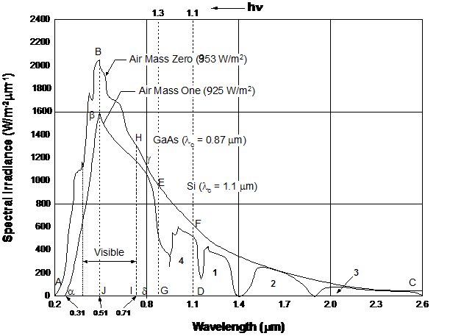

Fig. 4. Solar spectrum under AMO and AM1.

**Solution:**

Q5(a) Long wavelength losses for AM1

With reference to the above figure, in area of region 1, 2 & 3, the solar power is:

Region #1 = 0.5*456*0.3 = 68.4 W/m2

Region #2 = 0.5*297.6*0.5 = 74.4W/m2

Region #3 = 51.5*0.7 = 36.05 W/m2

Total long wavelength photons loss = 68.4+72.69+35.77 = 176.86 W/m2

Q5(b) Calculate the excess energy lost in the spectral range represented by triangle J for AM1.

The area of triangle J = [1600*(0.51 – 0.31)]/2 = 160 W/m2.

The average photon energy hav in triangle J is

(1.24/0.31 + 1.24/0.51)/2 = (4.0 + 2.43)/2= 6.43/2 = 3.215 eV.

Excess energy per photon not used in creating electron-hole pairs in Si (Eg=1.1eV) is

3.215-1.1 = 2.115eV.

**Excess energy not converted into electron-hole pairs and is lost to heat in triangle J is**

(160/3.215)*2.115=105.25 W/m2

**Correction:** The value listed in this question of 298.5 W/m2 is the total excess energy loss in the entire spectrum, not in triangleJ.

Q.6(a) What is long wavelength loss in InxGa1-xAsyP1-y with x =0.7 and y=0.54.

(b) What is the excess energy loss for green photons at wavelength of 585nm?

**Solution Q.6(a)**

Long wavelength loss in In0.7Ga0.3As0.54P0.46 which has a band gap of 0.8857eV (=1.24/1.4 m) is calculated from information in Q.1(c)

Note that absorption starts at a wavelength  = 1. 4 m.

Photons with wavelength greater than 1.4 m are not absorbed. From Fig. 4, these photons are represented by region 2 and region 3.

The area of region 2 and region 3 is calculated in solar design problem.

Photon power in region marked #2 is 72.69 W/m2

Photon power in region marked #3 is 35.77 W/m2.

The total power not absorbed by In0.7Ga0.3As0.54P0.46 is 108.46 W/m2.

Q6(b) What is the excess energy loss for green photons at wavelength of 585nm or 0.585 m?

For green photon wavelength  = 585 nm or 0.585 m.

The energy gap is 1.24/0.585 = 2.119 eV.

The excess energy = h – Eg of InGaAsP

= 2.119 – 0.8857 = 1.233 eV.

Q7. Label ISC, VOC, maximum power point Pm in solar cell characterization. Pm=Vm*Im

**Solution** Q7. Label ISC, VOC, maximum power point Pm in solar cell characterization. Pm=Vm*Im

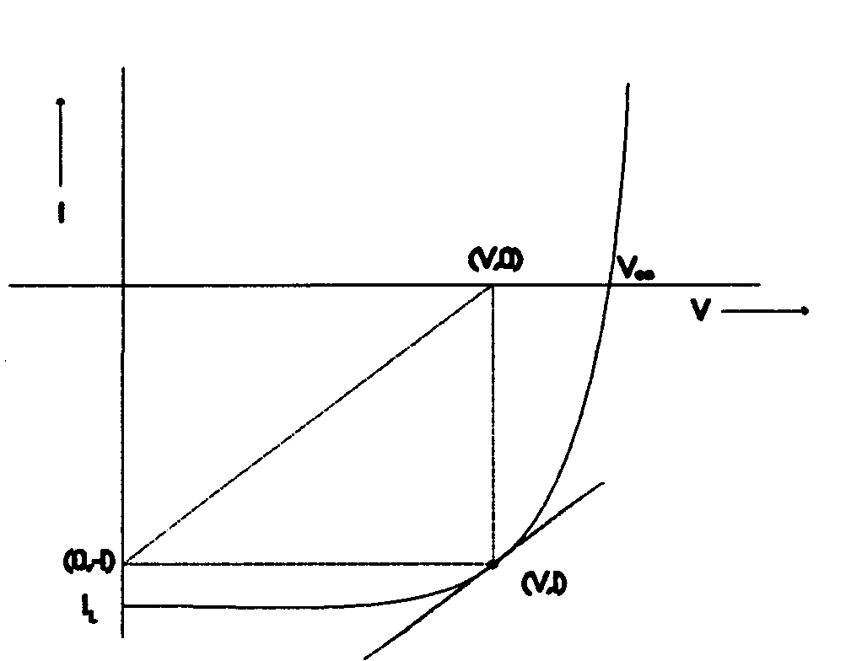Fig. 5

VOC

ISC

Pm= Im Vm

Q8. Solar energy is highest at following air mass m. **Circle all that apply.**

m=0 m=2 m=1 m=1.5

Q9. Average solar power received during a day is. **Circle one**

74mW/cm2 104mW/cm2 130mW/cm2

Q10. How many photons/s are needed to deliver 1mW of power at the wavelength of =0.5 m or photon energy of 2.48eV. Given photon energy h=1.24/0.5m = 2.48eV. **Circle one**

   

Q11. If you want to power your house with sunlight and need 10kW electrical power, how many panels N are needed? **Circle one**

Assume average solar power is 740W/m2; panel size 1m x 1m, and conversion efficiency of panel is 12%.

 

The electrical power produced per panel is 740*0.12.