L6 ECE 5212 Supplementary Notes 10042016 (Summary L5 09302016) F. Jain

**Absorption coefficient expressions for band-to-band direct and excitonic transitions, indirect transitions, band filling and band tailing.**

The power continuity equation gives power P at a point in semiconductor medium:

-∇ P(x,y,z) = W*ħ (Rate of absorption) (1)

The absorption coefficient is also defined in terms of probability of absorption PCV when an intensity I() is on for t sec duration on a sample of volume V having band-band transitions.

α = ħω $\frac{P_{cv}}{t}$ $\frac{1}{I\left(v\right)V}$* * (2)

PCV is expressed in terms of integral of one transition from state o in valence band to state m in the conduction band.

Pcv= (3)

Here, ϱ is join density of states expressed as: Here, mr is the reduced mass defined below.

ϱ ($hv$) = $[V4π{\left(2m_{r}\right)}^{\frac{3}{2}}{\left(hv-E_{g}\right)}^{\frac{1}{2}}]/h^{3}$ (3b)  (3C)

The probability is obtained by solving a time dependent Schrodinger equation having photon interaction as a perturbation Hamiltonian. It is shown [Moss et al.] that

Pmo(t)=* (4)

Here,  is the frequency of radiation and mo is the angular frequency corresponding to energy difference Em-Eo.

|= (5)

Here, pmo is the momentum matrix element which has three components.



${{|p}_{mo}|}^{2}={{|p}_{x,mo}|}^{2}+{{|p}_{y,mo}|}^{2}+{{|p}_{z,mo}|}^{2}$ $p is square of momentum$ (6)

Add Eq. 7-9

Using Eqs. 5, 4 and 3,

 (10)

ρ is assumed to be varying much slowly than in the integral, so it is taken out.

Using the standard integral, , [], or =t

Let us take another look at the integration:

, let , 

==(t/2)*2* t

 (11)

E. O. Kane has shown that

= (12)

Where,

(13)

P2 = , if (14)

Equation 14 and 12 gives

${{{|p}_{mo}|}^{2}}_{K=K_{o}}$ = $\frac{m_{o}^{2}E_{g}}{2m_{e}}$ (15)

Substitute equation 15 into equation 5 to obtain :

| (15b)

Substitute equation 15b into equation 4 to obtain Pmo:

Pmo(t) = $\frac{2e^{2}I\left(v\right)}{3m_{o}^{2}n_{r}ε_{r}cω^{2}}*\left[\frac{m_{o}^{2}E_{g}}{2m_{e}}\right]$ $\frac{\sin^{2}\left(ω-ω_{mo}\right)*t}{ħ^{2}({ω-ω_{mo})}^{2}}$* (15c)

Substitute Pmo from Eq. 15C in Eq. 3 to obtain PCV

(16A)

Subsisting for density of states 

(16B)

(17)

= A (h – Eg)1/2

Where A= , (17B)

A= 3.38 x 10-7 (nr)-1 (me/mo)1/2 in units of m-1 eV-1/2

**Excitonic transitions:**

For exciton transitions in direct band gap semiconductor, the absorption confident is derived byElliott (1957).

, $γ$ = ${\left(\frac{R}{ħω-E_{g}}\right)}^{1/2}$, (Eq. 2 page 164)

Here, R is the exciton binding energy Eex.

It is simplified to as photon energy approaches Eg or below.

, at h =Eg. (X, page 165 Eq. 4B)

The plot is shown below (Moss et al.)

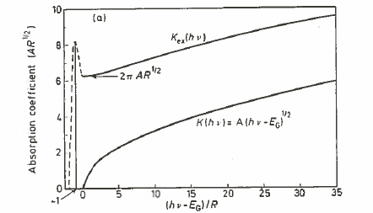

Excitonic peak at (h-Eg)/R =-1. That is, when h is Eex or R below Eg.

Case II: When photon energy is equal or less than band gap Eg.

, 

Now we can see from equation (4b):

 (6, page 166)

We see that Equation (2) expresses both direct band-to-band at energy above band gap and slightly below band gap.

**Case I:**

When photon energy is much larger than the band gap $hv≫E_{g}$,

$α_{ex}=\frac{2A{(ħω-E_{g})}^{1/2}γπ}{2πγ}$, this simplifies to $α_{ex}=A{(ħω-E_{g})}^{1/2}$,

which is $α_{ex}=α(ħω)$ (band-to-band)

|  |  |
| --- | --- |
|  |  |
| Absorption coefficient as a funciton h (without excitonic contributions). | Absorption with excitonic contribution shown in the form of peak below Eg. |

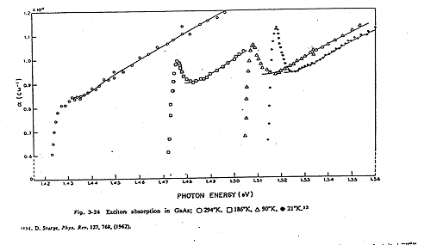

In the case of quantum wells, the excitonic binding energy Eex or R increases. In addition the direct band-to-band absorption coefficient is higher due to increased joint density of states magnitude.

**Calculation of exciton binding energy in bulk layers:** (LED Notes, part II)

The binding energy of an exciton ranges from 0.004 eV to 0.04 eV. In general the exciton binding energy Eex is:

 (1)

Where:, mr = reduced mass of the exciton given by

 (2)

q = electron charge, εr = dielectric constant of semiconductor or carbon nanotube etc.

h = Plank's constant

Binding energy can also be viewed as the dissociation energy. The latter being the energy needed to make the electron and hole free, overcoming the Columbic attraction.

Quantitatively, Eex = (13./r2)*(mr/mo); the unit is in electron Volt. This comes from the fact that the ionization potential of an hydrogen atom is 13.6eV = . Semiconductors that have small dielectric constant has larger exciton binding energy.

**Bound and free excitons:**

Excitons are free to move in semiconductor layer or they are bound to certain impurity sites. For example in p-type GaP (dopted with zinc), when electrons are injected they form excitons if GaP is doped with oxygen or nitrogen. In the case of oxygen, Zn-O locations provides sites for excitons to remain localized at those sites as energy levels facilitates exciton formation.

**Bound exciton at Zn- O site in p-GaP**

When the electron and hole forming an exciton recombine, this recombination results in photon emission. The probability of photon emission is as high (if not higher) as in the case of direct transitions. The energy of photon hv emitted upon the decay of an exciton at the Zn-O site is:

. (3)

if Eex = 0.04 eV

 (4)

or wavelength of emission is =1.24/h = 0.65 μm or 6500Å.

**Bound exciton at nitrogen sites in p-GaP**

An injected electron gets trapped at the nitrogen level, and subsequently binds a hole to form an exciton. The decay of this exciton results in a photon emission. The energy of the photon is

 (6)

If Eex = 0.004eV

 (7)

 (8)

Although GaP is an indirect energy gap material, the electron-hole recombination via excitonic decay is almost like a vertical (direct) transition. This is due to momentum rule relaxation as Heisenberg uncertainty principle (x*p ~h) provides larger latitude in momentum change (p) as x is very small due to bound excitons.

**Calculation of exciton binding energy in quantum wells:**

In quantum wells, the heavy and light hole bands split. In unstrained wells and compressive strained wells, the heavy holes are dominant where as in tensile strained quantum wells, light holes are dominant. Exciton binding is higher for smaller width quantum wells than the larger width wells for a given material/semiconductor layer.

|  |  |
| --- | --- |
| The electron and hole levels are computed (like HW).  Ee1g  Ehh1  Fig. 1(a) E⊥ = 0 | Fig.2(a) Reverse biased p-n diode with MQWs. |

**Change in electro-absorption and exciton peak shift due to E-field:**

The exciton binding energy as well as absorption plot is a funciton of electric field which is applied by an external radio frequency source. One way to apply is to make a p-n junction diode and reverse biasing it. This way the p and n- layers sandwich the multiple quantum well layers.

|  |  |
| --- | --- |
| E’hh1  E’e1g  Electron wave function  Hole wave function  Fig. 1(b) Quantum well in the presence of E⊥ | figure 5 |
| Electric field moves the electron and holes in different positions. This reduces absorption as well as excitonic binding energy. | Fig. 2(b) Absorption/responsivity as a funciton of applied voltage or electric field. |

The electric field also changes the electron E’e1and hole E’hh1energy levels. The change in electron energy levels and change in exciton binding energy E’ex results in the photon energy value at which the exciton absorption peaks. See Fig. 2(b).

Note that the band-to-band absorption due to free carriers is not shown in Fig. 2(b). It is to the right of plots shown here. It varies as = A (h – Eg)1/2.

**Change in electro-refraction in multiple quantum wells due to E-field:**

Index of refraction nc is complex when there are losses as photons travel in the medium.

nc= nr – i k

Where extinction coefficient is which is k = α/4, here alpha is the absorption coefficient. The square root of permittivity  is nc.

nc= nr – i k = (r  i)1/2

**The imaginary part of the permittivity is given by:**

The imaginary part i = 2nr , alpha is absorption coefficient, lambda is the wavelength and nr the real part of index of refraction.

i=2nr  e2/(m2o2)]*(Density of states)*(transition matrix element)*(polarization factor)*(Line shape funciton). Ref. W. Huang, UCONN Ph.D. thesis 1995]

Gaussian Line shape function: L(E)=[1/()1/2]*exp[-(ho-h)2/2], =h/(ln2)-1/2, =1.54*10-13 s.

The density of states changes with quantum well, quantum wire and dots. Transition matrix element involves wave functions in one, two or three dimensional confinement.

**The real part r is related to imaginary part i as**

**The imaginary and real and index of refraction are:**

**Use i and  relation above to recognize various terms in the following gain expression using excitons: Note gain coefficient g = - (fc + fv -1); here fc and fv are the Fermi distributions for electrons and holes.**



**Indirect band-to-band transitions: summary (pages157, 159-160)**

1. Steps:  Definition

Initial state ‘0’, intermediate state ‘i’ or ‘i’’, and final state ‘m’. Indirect transition can take place in two ways:

(a) 

Process (a) is dominant if 

The probability that an electron makes a transition from the initial ‘0’ to the final ‘m’ state is , which is:

1.  (2)

Eq.2 is obtained using second order perturbation theory.

Note that  2(b)

(Direct transition) 

 is the matrix element which represents electron-phonon interaction. ‘+’ sign represents phonon emission and the ‘-‘ is for phonon absorption.

Qualitatively,



 is the number of phonons in a particular mode in the crystal of volume *V*.

By definition, 4)  (or the occupancy of the qth mode)

5)

The energy balance equations are:



1. is obtained by summing  over all pairs of initial states (in the valence band) and all final states (in the conduction band).

7)  and

1. 

Where 

Eq.2, 7 & 8 give:



Density of states (in volume V)



Conservation of energy – just like joint density of states



Thus, Eq.9 integral is

Or for phonon emission



Combining Eq.1 with Eq.11, we get

12)

13)

Jα

C

Eg

Eg+EP

 This is:

Jα

C

Eg

Eg+EP

14)

**Exciton transitions in indirect gap semiconductors** 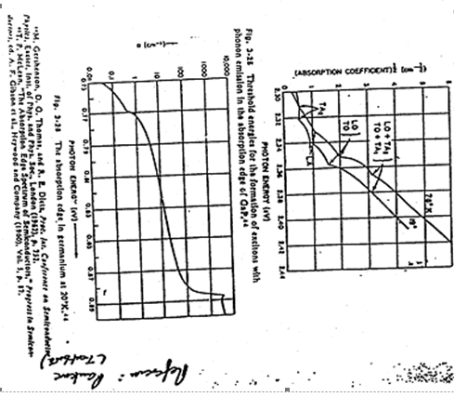

Jα

C

Eg

Eg+EP

**Band-to band transitions in heavily doped semiconductors: band filling and band tailing: (174-181)**

Band filling takes place in low energy gap semiconductors such as InSb where effective mass for electrons and holes is very small as compared with Si and GaAs.